 | MANDATORY DISCLOSURE
 | Mandatory Disclosure | updated on 14.02.2017
1 | AICTE File No. | South-West/1-2811930414/2016/EOA
 | Date & Period of last approval | 05.04.2016 Period 2016-17
2 | Name of the Institution | NORTH MALABAR INSTITUTE OF TECHNOLOGY
 | Address of the Institution | NELLIYADUKAM
 |  | PARKALAI
 |  | KANHANGAD
 | City & Pin Code | KASARGODE - 671531
 | State / UT | KERALA
 | Phone number with STD code | 0467-2440024
 | FAX number with STD Code | 04985-205907
 | Office hours at the Institution | 9 AM TO 5.00 PM
 | Academic hours at the Institution | 9.00 AM TO 4.00 PM
 | Email | info@nmitkerala.ac.in
 | Website | www.nmitkerala.ac.in

 | Nearest Railway Station (dist in Km) | Kanhangad - 9 KMS
 | Nearest Airport (dist in Km) | Mangalore - 100 KMS
3 | Type of Institution | Private-Self Financed
 | Category (1) of the Institution | Non Minority
 | Category (2) of the Institution | Co-Ed
4 | Name of the organization running the Institution | North Malabar Educational & Charitable Trust
 | Type of the organization | Public Charitable Trust
 | Address of the organization | 20 – D1 & D5, Municipal Office Building
 |  | Payyanur, Kannur District.
 | Registered with | Sub Registrar’s Office, Payyanur
 | Registration date | 04/09/2008
 | Website of the organization | www.nmitkerala.ac.in
5 | Name of the affiliating University / Board | KANNUR UNIVERSITY
 | Address | MANGATTUPARAMBA, KANNUR UNIVERSITY P.O, KANNUR DT, KERALA-670 567
 | Website | www.kannuruniversity.ac.in
 | Latest affiliation period | 2016-17
6 | Name of Principal / Director | DR. SURESAN PARETH
 | Exact Designation | PRINCIPAL
 | Phone number with STD code | 0467-2440024, 0467-3983000
 | FAX number with STD code | 0467-3983006
 | Email | principal@nmitkerala.ac.in
 | Highest Degree | Ph. D
 | Field of specialization | Computer Science and Engineering
7 | Governing Board Members | See Annexure No.1
 | Frequency of meetings & date of last meeting | Twice in a year -20.12.2015
8 | Academic Advisory Body | See Annexure No.2
 | Frequency of meetings & date of last meeting | Twice in a year-20.12.2015
9 | Organizational Chart | See Annexure No.3
10 | Student feedback mechanism Institutional Governance/faculty performance | We have devised a feedback system for getting students opinion on faculty performance and institutional governance. Proper follow up action will be taken to correct the anomalies if any.
11 | Grievance redressal mechanism for faculty, staff and students | Compliance and Redressal committee is functioning in our college. Grievances are thoroughly discussed by the Committee and remedial measures are implemented.

12.1 | Name of the Department* | CIVIL ENGINEERING
 | Course | B.TECH. CIVIL ENGINEERING
 | Level | UG /DEGREE
 | 1st Year of approval by the Council | 2012-13
 | Year wise Sanctioned Intake | CAY1 60 CAY2 60 CAY3 60 CAY4 60
 | Year wise Actual Admissions | CAY1 40 CAY2 60 CAY3 50 CAY4 37
 | Cut off marks –General quota | 50% for Mathematics &50% P+C+M
 | % Students passed with Distinction | NA
 | % Students passed with First Class | NA
 | Students Placed | NA
 | Average Pay package, Rs./Year | NA
 | Students opted for Higher Studies | NA
 | Accreditation Status of the course | Not Accredited
 | Doctoral Courses | No
 | Foreign Collaborations, if any | No
 | Professional Society Memberships | No
 | Professional activities | Yet to started
 | Consultancy activities | No
 | Grants fetched | No
 | Departmental Achievements
 | Distinguished Alumni | No

12.2 | Name of the Department* | MECHANICAL ENGINEERING
 | Course | B.TECH MECHANICAL ENGINEERING
 | Level | UG /DEGREE
 | 1st Year of approval by the Council | 2012-13
 | Year wise Sanctioned Intake | CAY1 60 CAY2 60 CAY3 60 CAY4 60
 | Year wise Actual Admissions | CAY1 46 CAY2 69 CAY3 69 CAY4 42
 | Cut off marks –General quota | 50% for Mathematics & 50% P+C+M
 | % Students passed with Distinction | NA
 | % Students passed with First Class | NA
 | Students Placed | NA
 | Average Pay package, Rs./Year | NA
 | Students opted for Higher Studies | NA
 | Accreditation Status of the course | Not Accredited
 | Doctoral Courses | No
 | Foreign Collaborations, if any | No
 | Professional Society Memberships | No
 | Professional activities | No
 | Consultancy activities | No
 | Grants fetched | No
 | Departmental Achievements
 | Distinguished Alumni | No

12.3 | Name of the Department* | ELECTRONICS & COMMUNICATION ENGINEERING
 | Course | B.TECH. ELECTRONICS & COMMUNICATION ENGINEERING
 | Level | UG /DEGREE
 | 1st Year of approval by the Council | 2012-13
 | Year wise Sanctioned Intake | CAY1 60 CAY2 60 CAY3 60 CAY4 60
 | Year wise Actual Admissions | CAY1 11 CAY2 28 CAY3 25 CAY4 32
 | Cut off marks –General quota | 50% for Mathematics & 50% P+C+M
 | % Students passed with Distinction | NA
 | % Students passed with First Class | NA
 | Students Placed | NA
 | Average Pay package, Rs./Year | NA
 | Students opted for Higher Studies | NA
 | Accreditation Status of the course | Not Accredited
 | Doctoral Courses | No
 | Foreign Collaborations, if any | No
 | Professional Society Memberships | No
 | Professional activities | No
 | Consultancy activities | No
 | Grants fetched | No
 | Departmental Achievements
 | Distinguished Alumni | No

12.4 | Name of the Department* | ELECTRICAL AND ELECTRONICS ENGINEERING
 | Course | B.TECH. ELECTRICAL & ELECTRONICS ENGINEERING
 | Level | UG /DEGREE
 | 1st Year of approval by the Council | 2012-13
 | Year wise Sanctioned Intake | CAY 60 CAY 60 CAY 60 CAY 60
 | Year wise Actual Admissions | CAY 7 CAY 22 CAY 12 CAY 17
 | Cut off marks –General quota | 50% for Mathematics & 50% P+C+M
 | % Students passed with Distinction | NA
 | % Students passed with First Class | NA
 | Students Placed | NA
 | Average Pay package, Rs./Year | NA
 | Students opted for Higher Studies | NA
 | Accreditation Status of the course | Not Accredited
 | Doctoral Courses | No
 | Foreign Collaborations, if any | No
 | Professional Society Memberships | No
 | Professional activities | No
 | Consultancy activities | No
 | Grants fetched | No
 | Departmental Achievements
 | Distinguished Alumni | No

12.5 | Name of the Department* | COMPUTER SCIENCE & ENGINEERING
 | Course | B.TECH. COMPUTER SCIENCE & ENGINEERING
 | Level | UG /DEGREE
 | 1st Year of approval by the Council | 2012-13
 | Year wise Sanctioned Intake | CAY 60 CAY 60 CAY 60 CAY 60
 | Year wise Actual Admissions | CAY 43 CAY 58 CAY 50 CAY 43
 | Cut off marks –General quota | 50% for Mathematics & 50% P+C+M
 | % Students passed with Distinction | NA
 | % Students passed with First Class | NA
 | Students Placed | NA
 | Average Pay package, Rs./Year | NA
 | Students opted for Higher Studies | NA
 | Accreditation Status of the course | Not Accredited
 | Doctoral Courses | No
 | Foreign Collaborations, if any | No
 | Professional Society Memberships | No
 | Professional activities | No
 | Consultancy activities | No
 | Grants fetched | No
 | Departmental Achievements
 | Distinguished Alumni | No

13.1 | Name of Teaching Staff* | 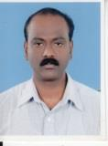  DR. SURESAN PARETH
 | Designation | PRINCIPAL
 | Department | COMPUTER SCIENCE AND ENGINEERING
 | Date of Joining the Institution | 22-01-2014
 | Qualifications with Class/Grade | BE - FIRST CLASS M.Tech - FIRST CLASS Ph.D
 | Total Experience in Years | Teaching - 13 Industry - 7
 | Papers Published | 4
 | Papers Presented in Conferences | National - International - 4
 | PhD Guide? Give field & University
 | PhDs / Projects Guided
 | Books Published / IPRs/ Patents | INTERNATIONAL JOURNALS - 11
 | Professional Memberships | Life member in IAENG.
 | Consultancy Activities | NIL
 | Awards | NIL
 | Grants fetched | NIL
 | Interaction with Professional Institutions | NIL

13.2 | Name of Teaching Staff* | 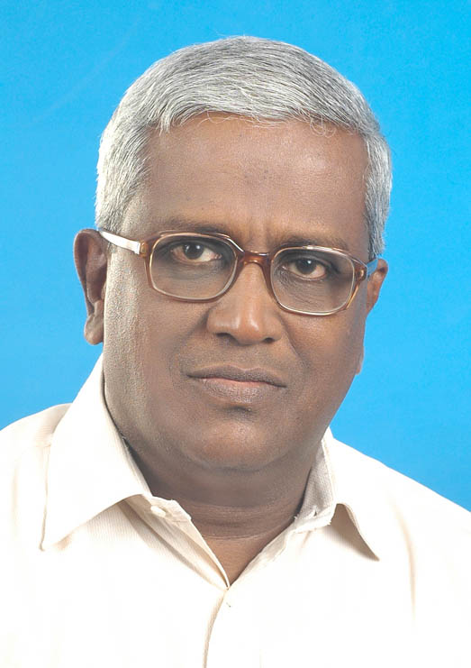  Prof. JACOB JOHN
 | Designation | ASSOCIATE PROFESSOR
 | Department | MECHANICAL ENGINEERING
 | Date of Joining the Institution | 01-09-2012
 | Qualifications with Class/Grade | B.Tech- FIRST CLASS FIE
 | Total Experience in Years | Teaching - 20 Industry - 18 Research - NIL
 | Papers Published | National - NIL International - NIL
 | Papers Presented in Conferences | National- NIL International- NIL
 | PhD Guide? Give field & University | Field- NIL University- NIL
 | PhDs / Projects Guided | PhDs- NIL Projects at Masters level- NIL
 | Books Published / IPRs/ Patents | NIL
 | Professional Memberships | NIL
 | Consultancy Activities | NIL
 | Awards | NIL
 | Grants fetched | NIL
 | Interaction with Professional Institutions | NIL

13.3 | Name of Teaching Staff* | 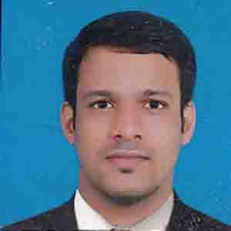  Prof. RANJITH T. V.
 | Designation | ASSISTANT PROFESSOR
 | Department | MECHANICAL ENGINEERING
 | Date of Joining the Institution | 01-09-2012
 | Qualifications with Class/Grade | BTech - FIRST CLASS MTech - FIRST CLASS
 | Total Experience in Years | Teaching- 5 Industry- NIL Research- NIL
 | Papers Published | National- NIL International- NIL
 | Papers Presented in Conferences | National- NIL International- NIL
 | PhD Guide? Give field & University | Field- NIL University- NIL
 | PhDs / Projects Guided | PhDs- NIL Projects at Masters level- NIL
 | Books Published / IPRs/ Patents | NIL
 | Professional Memberships | NIL
 | Consultancy Activities | NIL
 | Awards | NIL
 | Grants fetched | NIL
 | Interaction with Professional Institutions | NIL

13.4 | Name of Teaching Staff* | 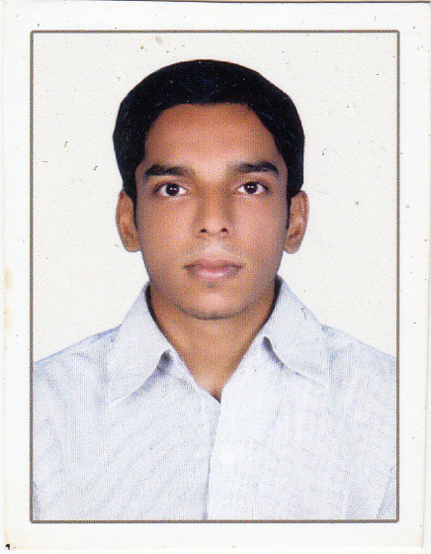  Prof. JIJITH P K
 | Designation | ASSISTANT PROFESSOR
 | Department | MECHANICAL ENGINEERING
 | Date of Joining the Institution | 16-06-2014
 | Qualifications with Class/Grade | BTech - FIRST CLASS MTech - FIRST CLASS
 | Total Experience in Years | Teaching- 3 Industry- NIL Research- NIL
 | Papers Published | National- NIL International- NIL
 | Papers Presented in Conferences | National- NIL International- NIL
 | PhD Guide? Give field & University | Field- NIL University- NIL
 | PhDs / Projects Guided | PhDs- NIL Projects at Masters level- NIL
 | Books Published / IPRs/ Patents | NIL
 | Professional Memberships | NIL
 | Consultancy Activities | NIL
 | Awards | NIL
 | Grants fetched | NIL
 | Interaction with Professional Institutions | NIL

13.5 | Name of Teaching Staff* | 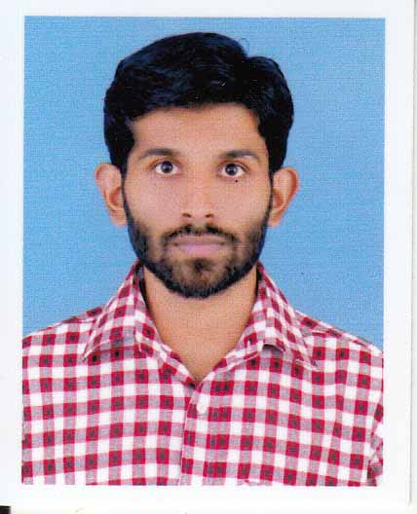  Prof. JUBIN JAMES
 | Designation | ASSISTANT PROFESSOR
 | Department | MECHANICAL ENGINEERING
 | Date of Joining the Institution | 01-09-2013
 | Qualifications with Class/Grade | BTech - FIRST CLASS MTech - FIRST CLASS
 | Total Experience in Years | Teaching- 4 Industry- NIL Research- NIL
 | Papers Published | National- NIL International- NIL
 | Papers Presented in Conferences | National- NIL International- NIL
 | PhD Guide? Give field & University | Field- NIL University- NIL
 | PhDs / Projects Guided | PhDs- NIL Projects at Masters level- NIL
 | Books Published / IPRs/ Patents | NIL
 | Professional Memberships | NIL
 | Consultancy Activities | NIL
 | Awards | NIL
 | Grants fetched | NIL
 | Interaction with Professional Institutions | NIL

13.6 | Name of Teaching Staff* | 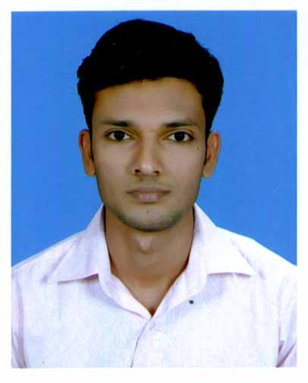  Prof. PRAJINLAL K P
 | Designation | ASSISTANT PROFESSOR
 | Department | MECHANICAL ENGINEERING
 | Date of Joining the Institution | 17-06-2013
 | Qualifications with Class/Grade | BTech - FIRST CLASS MTech - FIRST CLASS
 | Total Experience in Years | Teaching- 5 Industry- NIL Research- NIL
 | Papers Published | National- NIL International- NIL
 | Papers Presented in Conferences | National- NIL International- NIL
 | PhD Guide? Give field & University | Field- NIL University- NIL
 | PhDs / Projects Guided | PhDs- NIL Projects at Masters level- NIL
 | Books Published / IPRs/ Patents | NIL
 | Professional Memberships | NIL
 | Consultancy Activities | NIL
 | Awards | NIL
 | Grants fetched | NIL
 | Interaction with Professional Institutions | NIL

13.7 | Name of Teaching Staff* | 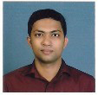  Prof. RAJEESH P
 | Designation | ASSISTANT PROFESSOR
 | Department | MECHANICAL ENGINEERING
 | Date of Joining the Institution | 02-05-2014
 | Qualifications with Class/Grade | BTech - FIRST CLASS MTech - FIRST CLASS
 | Total Experience in Years | Teaching- 2 Industry- 1 Research- NIL
 | Papers Published | National- NIL International- NIL
 | Papers Presented in Conferences | National- NIL International- NIL
 | PhD Guide? Give field & University | Field- NIL University- NIL
 | PhDs / Projects Guided | PhDs- NIL Projects at Masters level- NIL
 | Books Published / IPRs/ Patents | NIL
 | Professional Memberships | NIL
 | Consultancy Activities | NIL
 | Awards | NIL
 | Grants fetched | NIL
 | Interaction with Professional Institutions | NIL

13.8 | Name of Teaching Staff* | 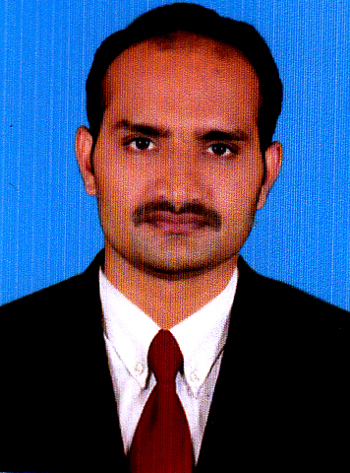  Prof. VISHNU PRASAD
 | Designation | ASSISTANT PROFESSOR
 | Department | MECHANICAL ENGINEERING
 | Date of Joining the Institution | 25-01-2016
 | Qualifications with Class/Grade | BTech - FIRST CLASS MTech - FIRST CLASS
 | Total Experience in Years | Teaching- 2 Industry- Research- NIL
 | Papers Published | National- NIL International- NIL
 | Papers Presented in Conferences | National- NIL International- NIL
 | PhD Guide? Give field & University | Field- NIL University- NIL
 | PhDs / Projects Guided | PhDs- NIL Projects at Masters level- NIL
 | Books Published / IPRs/ Patents | NIL
 | Professional Memberships | NIL
 | Consultancy Activities | NIL
 | Awards | NIL
 | Grants fetched | NIL
 | Interaction with Professional Institutions | NIL

13.9 | Name of Teaching Staff* | 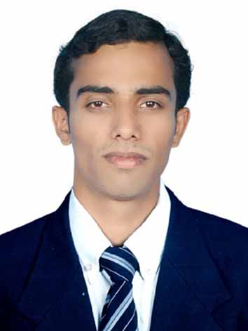  Prof. ANOOP AV
 | Designation | ASSISTANT PROFESSOR
 | Department | ELECTRONICS AND COMMUNICATIONS ENGINEERING
 | Date of Joining the Institution | 14-06-2013
 | Qualifications with Class/Grade | BTech - FIRST CLASS MTech - FIRST CLASS
 | Total Experience in Years | Teaching - 5 Industry - NIL Research - NIL
 | Papers Published | National - NIL International - NIL
 | Papers Presented in Conferences | National - NIL International - NIL
 | PhD Guide? Give field & University | Field - NIL University - NIL
 | PhDs / Projects Guided | PhDs - NIL Projects at Masters level - NIL
 | Books Published / IPRs/ Patents | NIL
 | Professional Memberships | NIL
 | Consultancy Activities | NIL
 | Awards | NIL
 | Grants fetched | NIL
 | Interaction with Professional Institutions | NIL

13.10 | Name of Teaching Staff* | 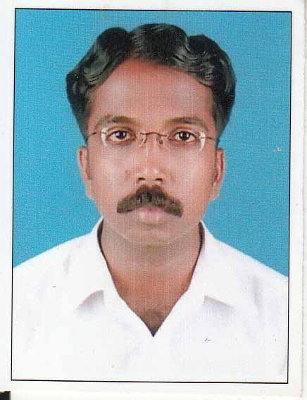  Prof. RAGHU T V
 | Designation | ASSISTANT PROFESSOR
 | Department | COMPUTER SCIENCE AND ENGINEERING
 | Date of Joining the Institution | 19-06-2013
 | Qualifications with Class/Grade | BTech - FIRST CLASS M.Tech - FIRST CLASS
 | Total Experience in Years | Teaching - 7 Industry - Research
 | Papers Published | National - NIL International - NIL
 | Papers Presented in Conferences | National - NIL International - NIL
 | PhD Guide? Give field & University | Field - NIL University - NIL
 | PhDs / Projects Guided | PhDs - NIL Projects at Masters level - NIL
 | Books Published / IPRs/ Patents | NIL
 | Professional Memberships | NIL
 | Consultancy Activities | NIL
 | Awards | NIL
 | Grants fetched | NIL
 | Interaction with Professional Institutions | NIL

13.11 | Name of Teaching Staff* | 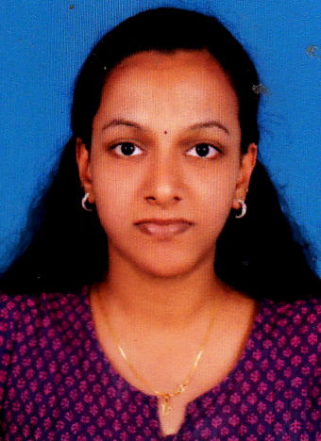  Prof. VINEETHA C
 | Designation | ASSISTANT PROFESSOR
 | Department | COMPUTER SCIENCE AND ENGINEERING:
 | Date of Joining the Institution | 02-07-2015
 | Qualifications with Class/Grade | BTech - FIRST CLASS M.Tech - FIRST CLASS
 | Total Experience in Years | Teaching - 1 Industry - Research
 | Papers Published | National - NIL International - NIL
 | Papers Presented in Conferences | National - NIL International - NIL
 | PhD Guide? Give field & University | Field - NIL University - NIL
 | PhDs / Projects Guided | PhDs - NIL Projects at Masters level - NIL
 | Books Published / IPRs/ Patents | NIL
 | Professional Memberships | NIL
 | Consultancy Activities | NIL
 | Awards | NIL
 | Grants fetched | NIL
 | Interaction with Professional Institutions | NIL

13.12 | Name of Teaching Staff* | 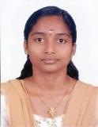  SREEDIVYA TK
 | Designation | LECTURER
 | Department | COMPUTER SCIENCE AND ENGINEERING:
 | Date of Joining the Institution | 16-6-2014
 | Qualifications with Class/Grade | BTech - FIRST CLASS
 | Total Experience in Years | Teaching - Industry - Research
 | Papers Published | National - NIL International - NIL
 | Papers Presented in Conferences | National - NIL International - NIL
 | PhD Guide? Give field & University | Field - NIL University - NIL
 | PhDs / Projects Guided | PhDs - NIL Projects at Masters level - NIL
 | Books Published / IPRs/ Patents | NIL
 | Professional Memberships | NIL
 | Consultancy Activities | NIL
 | Awards | NIL
 | Grants fetched | NIL
 | Interaction with Professional Institutions | NIL

13.13 | Name of Teaching Staff* | 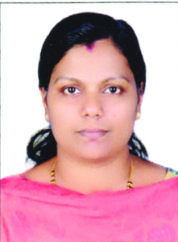  Prof. BABY SUNITHA VP
 | Designation | ASSISTANT PROFESSOR
 | Department | COMPUTER SCIENCE AND ENGINEERING:
 | Date of Joining the Institution | 14-01-2015
 | Qualifications with Class/Grade | BTech - FIRST CLASS M.Tech - FIRST CLASS
 | Total Experience in Years | Teaching - 5 Industry - 0 Research
 | Papers Published | National - NIL International - NIL
 | Papers Presented in Conferences | National - NIL International - NIL
 | PhD Guide? Give field & University | Field - NIL University - NIL
 | PhDs / Projects Guided | PhDs - NIL Projects at Masters level - NIL
 | Books Published / IPRs/ Patents | NIL
 | Professional Memberships | NIL
 | Consultancy Activities | NIL
 | Awards | NIL
 | Grants fetched | NIL
 | Interaction with Professional Institutions | NIL

13.14 | Name of Teaching Staff* | 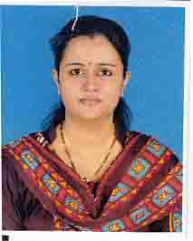  MRS. NITHA RANI M.
 | Designation | LECTURER
 | Department | COMPUTER SCIENCE & ENGINEERING:
 | Date of Joining the Institution | 01-09-2012
 | Qualifications with Class/Grade | BSc - SECOND CLASS MSc - FIRST CLASS
 | Total Experience in Years | Teaching- 3 Industry- 1 Research- NIL
 | Papers Published | National- NIL International- NIL
 | Papers Presented in Conferences | National- NIL International- NIL
 | PhD Guide? Give field & University | Field- NIL University- NIL
 | PhDs / Projects Guided | PhDs- NIL Projects at Masters level- NIL
 | Books Published / IPRs/ Patents | NIL
 | Professional Memberships | NIL
 | Consultancy Activities | NIL
 | Awards | NIL
 | Grants fetched | NIL
 | Interaction with Professional Institutions | NIL

13.15 | Name of Teaching Staff* | 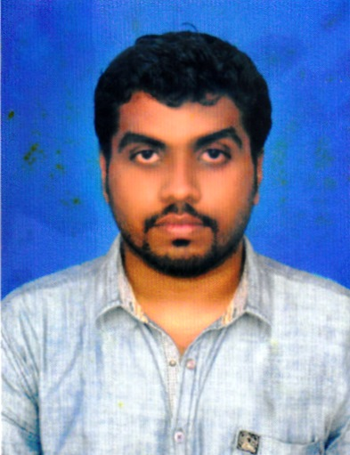  Prof. JANESH KRISHNAN
 | Designation | ASSISTANT PROFESSOR
 | Department | CIVIL ENIGINEERING:
 | Date of Joining the Institution | 30-07-2014
 | Qualifications with Class/Grade | BTech - FIRST CLASS MTech - FIRST CLASS
 | Total Experience in Years | Teaching-3 Industry- 1 Research- NIL
 | Papers Published | National- Nil International- Nil
 | Papers Presented in Conferences | National- Nil International- Nil
 | PhD Guide? Give field & University | Field- NIL University- NIL
 | PhDs / Projects Guided | PhDs - NIL Projects at Masters level- NIL
 | Books Published / IPRs/ Patents | Nil
 | Professional Memberships | Nil
 | Consultancy Activities | Nil
 | Awards | Nil
 | Grants fetched | Nil
 | Interaction with Professional Institutions | Nil

13.16 | Name of Teaching Staff* | 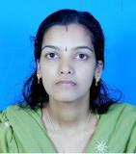  Prof. PRIYA A
 | Designation | ASSISTANT PROFESSOR
 | Department | CIVIL ENIGINEERING:
 | Date of Joining the Institution | 04-07-2016
 | Qualifications with Class/Grade | BTech - FIRST CLASS MTech - FIRST CLASS
 | Total Experience in Years | Teaching-4 Industry- 1 Research- NIL
 | Papers Published | National- Nil International- Nil
 | Papers Presented in Conferences | National- Nil International- Nil
 | PhD Guide? Give field & University | Field- NIL University- NIL
 | PhDs / Projects Guided | PhDs - NIL Projects at Masters level- NIL
 | Books Published / IPRs/ Patents | Nil
 | Professional Memberships | Nil
 | Consultancy Activities | Nil
 | Awards | Nil
 | Grants fetched | Nil
 | Interaction with Professional Institutions | Nil

13.17 | Name of Teaching Staff* | 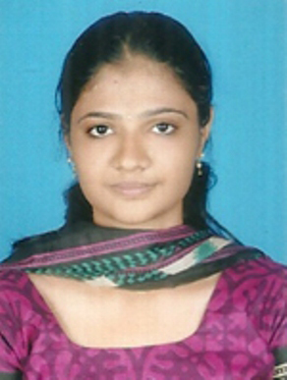  Prof. SRUTHI T K
 | Designation | ASSISTANT PROFESSOR
 | Department | CIVIL ENIGINEERING:
 | Date of Joining the Institution | 26-10-2015
 | Qualifications with Class/Grade | BTech - FIRST CLASS MTech - FIRST CLASS
 | Total Experience in Years | Teaching-1 Industry- 1 Research- NIL
 | Papers Published | National- Nil International- Nil
 | Papers Presented in Conferences | National- Nil International- Nil
 | PhD Guide? Give field & University | Field- NIL University- NIL
 | PhDs / Projects Guided | PhDs - NIL Projects at Masters level- NIL
 | Books Published / IPRs/ Patents | Nil
 | Professional Memberships | Nil
 | Consultancy Activities | Nil
 | Awards | Nil
 | Grants fetched | Nil
 | Interaction with Professional Institutions | Nil

13.18 | Name of Teaching Staff* | 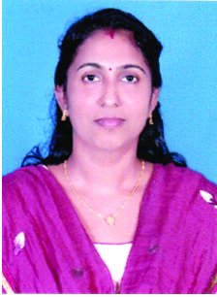  Prof. SANDHYA K
 | Designation | ASSISTANT PROFESSOR
 | Department | ELECTRICAL & ELECTRONICS ENGG:
 | Date of Joining the Institution | 12-11-2014
 | Qualifications with Class/Grade | BTech - FIRST CLASS ME - FIRST CLASS
 | Total Experience in Years | Teaching-4 Industry- Research- NIL
 | Papers Published | National- Nil International- Nil
 | Papers Presented in Conferences | National- Nil International- Nil
 | PhD Guide? Give field & University | Field- NIL University- NIL
 | PhDs / Projects Guided | PhDs - NIL Projects at Masters level- NIL
 | Books Published / IPRs/ Patents | Nil
 | Professional Memberships | Nil
 | Consultancy Activities | Nil
 | Awards | Nil
 | Grants fetched | Nil
 | Interaction with Professional Institutions | Nil

13.19 | Name of Teaching Staff* | 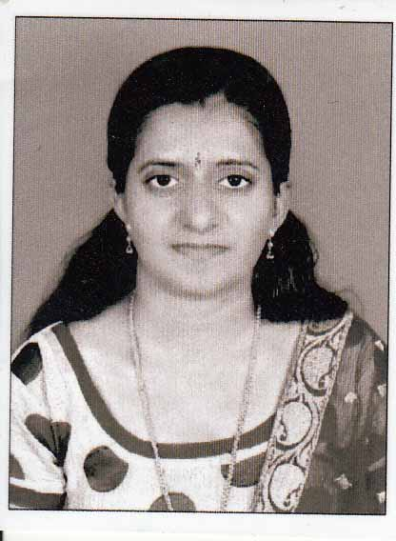  Prof. SRUTHI M
 | Designation | ASSISTANT PROFESSOR
 | Department | ELECTRICAL & ELECTRONICS ENGG:
 | Date of Joining the Institution | 17-06-2013
 | Qualifications with Class/Grade | BTech - FIRST CLASS ME - FIRST CLASS
 | Total Experience in Years | Teaching-5 Industry- Research- NIL
 | Papers Published | National- Nil International- Nil
 | Papers Presented in Conferences | National- Nil International- Nil
 | PhD Guide? Give field & University | Field- NIL University- NIL
 | PhDs / Projects Guided | PhDs - NIL Projects at Masters level- NIL
 | Books Published / IPRs/ Patents | Nil
 | Professional Memberships | Nil
 | Consultancy Activities | Nil
 | Awards | Nil
 | Grants fetched | Nil
 | Interaction with Professional Institutions | Nil

13.20 | Name of Teaching Staff* | 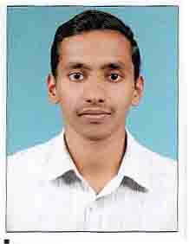  Prof. MANU THOMAS
 | Designation | ASSISTANT PROFESSOR
 | Department | ELECTRONICS & COMMUNICATION ENGG:
 | Date of Joining the Institution | 01-09-2012
 | Qualifications with Class/Grade | BTech - FIRST CLASS MTech - FIRST CLASS
 | Total Experience in Years | Teaching - 4 Industry - NIL Research - NIL
 | Papers Published | National - NIL International - NIL
 | Papers Presented in Conferences | National- NIL International- NIL
 | PhD Guide? Give field & University | Field- NIL University- NIL
 | PhDs / Projects Guided | PhDs- NIL Projects at Masters level- NIL
 | Books Published / IPRs/ Patents | NIL
 | Professional Memberships | NIL
 | Consultancy Activities | NIL
 | Awards | NIL
 | Grants fetched | NIL
 | Interaction with Professional Institutions | NIL

13.21 | Name of Teaching Staff* | 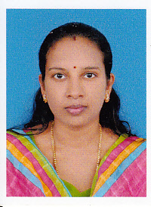  Prof. DHANYA K.
 | Designation | ASSISTANT PROFESSOR
 | Department | ELECTRICAL & ELECTRONICS ENGG:
 | Date of Joining the Institution | 01-09-2012
 | Qualifications with Class/Grade | BTech - SECOND CLASS MTech - FIRST CLASS
 | Total Experience in Years | Teaching - 4 Industry - 3 Research - NIL
 | Papers Published | National- NIL International- NIL
 | Papers Presented in Conferences | National- NIL International- NIL
 | PhD Guide? Give field & University | Field- NIL University- NIL
 | PhDs / Projects Guided | PhDs- NIL Projects at Masters level- NIL
 | Books Published / IPRs/ Patents | NIL
 | Professional Memberships | NIL
 | Consultancy Activities | NIL
 | Awards | NIL
 | Grants fetched | NIL
 | Interaction with Professional Institutions | NIL

13.22 | Name of Teaching Staff* | 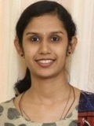  Prof. SRUTHI N PAUL
 | Designation | ASSISTANT PROFESSOR
 | Department | COMPUTER SCIENCE & ENGINEERING:
 | Date of Joining the Institution | 11-07-2016
 | Qualifications with Class/Grade | BTech - SECOND CLASS MTech - FIRST CLASS
 | Total Experience in Years | Teaching - 3 Industry - Research - NIL
 | Papers Published | National- NIL International- NIL
 | Papers Presented in Conferences | National- NIL International- NIL
 | PhD Guide? Give field & University | Field- NIL University- NIL
 | PhDs / Projects Guided | PhDs- NIL Projects at Masters level- NIL
 | Books Published / IPRs/ Patents | NIL
 | Professional Memberships | NIL
 | Consultancy Activities | NIL
 | Awards | NIL
 | Grants fetched | NIL
 | Interaction with Professional Institutions | NIL

13.23 | Name of Teaching Staff* | 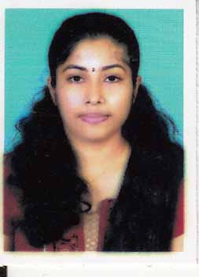  Prof. SRUTHI KRISHNAN
 | Designation | ASSISTANT PROFESSOR
 | Department | COMPUTER SCIENCE & ENGINEERING
 | Date of Joining the Institution | 01-01-2014
 | Qualifications with Class/Grade | BTech - FIRST CLASS MTech - FIRST CLASS
 | Total Experience in Years | Teaching- 2 Industry- NIL Research- NIL
 | Papers Published | National- NIL International- NIL
 | Papers Presented in Conferences | National- NIL International- NIL
 | PhD Guide? Give field & University | Field- NIL University- NIL
 | PhDs / Projects Guided | PhDs- NIL Projects at Masters level- NIL
 | Books Published / IPRs/ Patents | NIL
 | Professional Memberships | NIL
 | Consultancy Activities | NIL
 | Awards | NIL
 | Grants fetched | NIL
 | Interaction with Professional Institutions | NIL

13.24 | Name of Teaching Staff* | 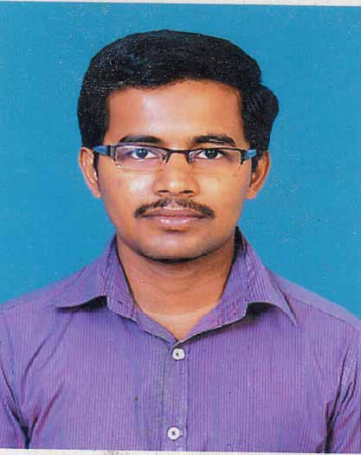  Prof. MANU C PERINGELIL.
 | Designation | ASSISTANT PROFESSOR
 | Department | CIVIL ENGINEERING
 | Date of Joining the Institution | 01-07-2013
 | Qualifications with Class/Grade | BTech - FIRST CLASS MTech - FIRST CLASS
 | Total Experience in Years | Teaching- 3 Industry- NIL Research- NIL
 | Papers Published | National- NIL International- NIL
 | Papers Presented in Conferences | National- NIL International- NIL
 | PhD Guide? Give field & University | Field- NIL University- NIL
 | PhDs / Projects Guided | PhDs- NIL Projects at Masters level- NIL
 | Books Published / IPRs/ Patents | NIL
 | Professional Memberships | NIL
 | Consultancy Activities | NIL
 | Awards | NIL
 | Grants fetched | NIL
 | Interaction with Professional Institutions | NIL

13.25 | Name of Teaching Staff* | 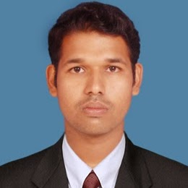  Prof. SRUTHIN BALACHANDRAN
 | Designation | ASSISTANT PROFESSOR
 | Department | ELECTRONICS & COMMUNICATION ENGG:
 | Date of Joining the Institution | 01-08-2014
 | Qualifications with Class/Grade | BTech - SECOND CLASS MTech - FIRST CLASS
 | Total Experience in Years | Teaching - 2 Industry - 9 Research - NIL
 | Papers Published | National - NIL International - NIL
 | Papers Presented in Conferences | National- NIL International- NIL
 | PhD Guide? Give field & University | Field- NIL University- NIL
 | PhDs / Projects Guided | PhDs- NIL Projects at Masters level- NIL
 | Books Published / IPRs/ Patents | NIL
 | Professional Memberships | NIL
 | Consultancy Activities | NIL
 | Awards | NIL
 | Grants fetched | NIL
 | Interaction with Professional Institutions | NIL

13.26 | Name of Teaching Staff* | 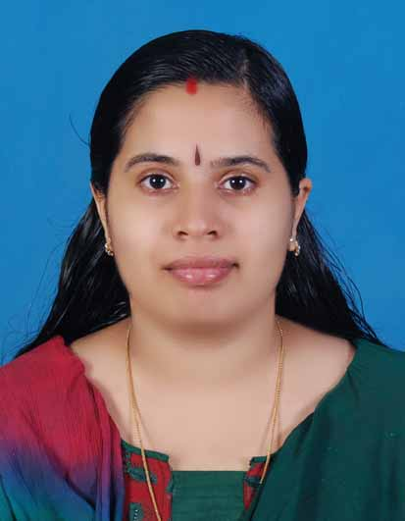  Prof. BINDU K P
 | Designation | ASSISTANT PROFESSOR
 | Department | ELECTRONICS & COMMUNICATION ENGG:
 | Date of Joining the Institution | 02-05-2014
 | Qualifications with Class/Grade | BTech - FIRST CLASS MTech - FIRST CLASS
 | Total Experience in Years | Teaching - 5 Industry - Research - NIL
 | Papers Published | National - NIL International - NIL
 | Papers Presented in Conferences | National- NIL International- NIL
 | PhD Guide? Give field & University | Field- NIL University- NIL
 | PhDs / Projects Guided | PhDs- NIL Projects at Masters level- NIL
 | Books Published / IPRs/ Patents | NIL
 | Professional Memberships | NIL
 | Consultancy Activities | NIL
 | Awards | NIL
 | Grants fetched | NIL
 | Interaction with Professional Institutions | NIL

13.27 | Name of Teaching Staff* | 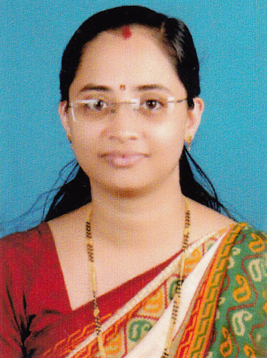  Prof. RADHIKA H
 | Designation | ASSISTANT PROFESSOR
 | Department | ELECTRONICS & COMMUNICATION ENGG:
 | Date of Joining the Institution | 30-12-2014
 | Qualifications with Class/Grade | BTech - FIRST CLASS MTech - FIRST CLASS
 | Total Experience in Years | Teaching - 8 Industry - Research - NIL
 | Papers Published | National - NIL International - NIL
 | Papers Presented in Conferences | National- NIL International- NIL
 | PhD Guide? Give field & University | Field- NIL University- NIL
 | PhDs / Projects Guided | PhDs- NIL Projects at Masters level- NIL
 | Books Published / IPRs/ Patents | NIL
 | Professional Memberships | NIL
 | Consultancy Activities | NIL
 | Awards | NIL
 | Grants fetched | NIL
 | Interaction with Professional Institutions | NIL

13.28 | Name of Teaching Staff* | 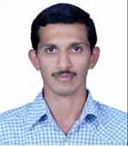  Prof. SOORAJ K
 | Designation | ASSISTANT PROFESSOR
 | Department | CIVIL ENGINEERING
 | Date of Joining the Institution | 26-06-2013
 | Qualifications with Class/Grade | BTech - FIRST CLASS MTech -
 | Total Experience in Years | Teaching - 3 Industry - NIL Research - NIL
 | Papers Published | National - NIL International - NIL
 | Papers Presented in Conferences | National- NIL International- NIL
 | PhD Guide? Give field & University | Field- NIL University- NIL
 | PhDs / Projects Guided | PhDs- NIL Projects at Masters level- NIL
 | Books Published / IPRs/ Patents | NIL
 | Professional Memberships | NIL
 | Consultancy Activities | NIL
 | Awards | NIL
 | Grants fetched | NIL
 | Interaction with Professional Institutions | NIL

13.29 | Name of Teaching Staff* | 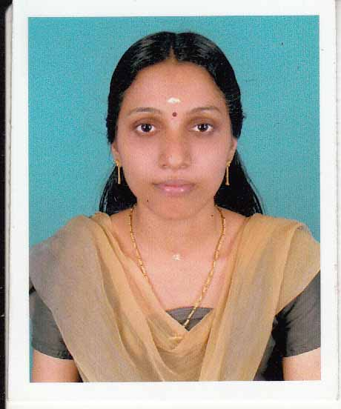  Prof. LAJITHA K V
 | Designation | ASSISTANT PROFESSOR
 | Department | ELECTRICAL AND ELECTRONICS ENGINEERING
 | Date of Joining the Institution | 17-06-2013
 | Qualifications with Class/Grade | BTech - FIRST CLASS ME - FIRST CLASS
 | Total Experience in Years | Teaching- 3 Industry- NIL Research- NIL
 | Papers Published | National- NIL International- NIL
 | Papers Presented in Conferences | National- NIL International- NIL
 | PhD Guide? Give field & University | Field- NIL University- NIL
 | PhDs / Projects Guided | PhDs- NIL Projects at Masters level- NIL
 | Books Published / IPRs/ Patents | NIL
 | Professional Memberships | NIL
 | Consultancy Activities | NIL
 | Awards | NIL
 | Grants fetched | NIL
 | Interaction with Professional Institutions | NIL

13.30 | Name of Teaching Staff* | 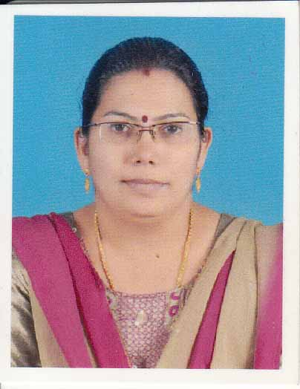  Prof. CHALANA K
 | Designation | ASSISTANT PROFESSOR
 | Department | ENGLISH
 | Date of Joining the Institution | 17-06-2013
 | Qualifications with Class/Grade | BA - SECOND CLASS MA - SECOND CLASS
 | Total Experience in Years | Teaching- 3 Industry- NIL Research- NIL
 | Papers Published | National- NIL International- NIL
 | Papers Presented in Conferences | National- NIL International- NIL
 | PhD Guide? Give field & University | Field- NIL University- NIL
 | PhDs / Projects Guided | PhDs- NIL Projects at Masters level- NIL
 | Books Published / IPRs/ Patents | NIL
 | Professional Memberships | NIL
 | Consultancy Activities | NIL
 | Awards | NIL
 | Grants fetched | NIL
 | Interaction with Professional Institutions | NIL

13.31 | Name of Teaching Staff* | 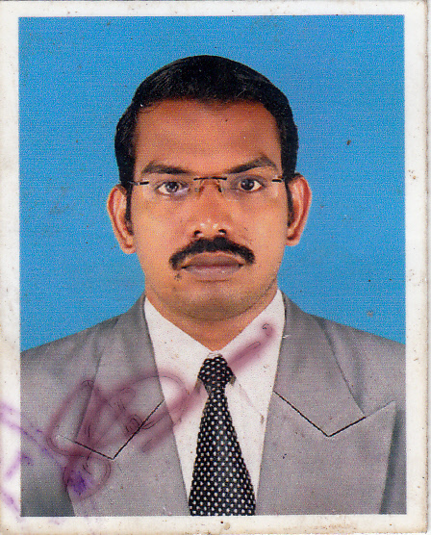  Prof. ABHILASH RAYAROTH
 | Designation | ASSISTANT PROFESSOR
 | Department | ENGLISH
 | Date of Joining the Institution | 01-07-2014
 | Qualifications with Class/Grade | B.Com(Co-Op) - FIRST CLASS MBA - FIRST CLASS
 | Total Experience in Years | Teaching- 7 Industry- NIL Research- NIL
 | Papers Published | National- NIL International- NIL
 | Papers Presented in Conferences | National- NIL International- NIL
 | PhD Guide? Give field & University | Field- NIL University- NIL
 | PhDs / Projects Guided | PhDs- NIL Projects at Masters level- NIL
 | Books Published / IPRs/ Patents | NIL
 | Professional Memberships | NIL
 | Consultancy Activities | NIL
 | Awards | NIL
 | Grants fetched | NIL
 | Interaction with Professional Institutions | NIL

13.32 | Name of Teaching Staff* | 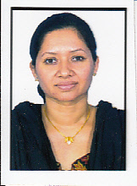  Prof. JOSHMY JOHN
 | Designation | ASSISTANT PROFESSOR
 | Department | CHEMISTRY
 | Date of Joining the Institution | 03-09-2012
 | Qualifications with Class/Grade | BSc- SECOND CLASS MSc- FIRST CLASS  M.Phil – FIRST CLASS
 | Total Experience in Years | Teaching- 12 Industry- NIL Research- NIL
 | Papers Published | National- NIL International- NIL
 | Papers Presented in Conferences | National- NIL International- NIL
 | PhD Guide? Give field & University | Field- NIL University- NIL
 | PhDs / Projects Guided | PhDs- NIL Projects at Masters level- NIL
 | Books Published / IPRs/ Patents | NIL
 | Professional Memberships | NIL
 | Consultancy Activities | NIL
 | Awards | NIL
 | Grants fetched | NIL
 | Interaction with Professional Institutions | NIL

13.33 | Name of Teaching Staff* | 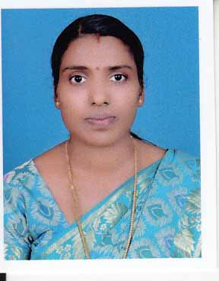  Prof. SOUMYA M
 | Designation | ASSISTANT PROFESSOR
 | Department | ELECTRONICS AND COMMUNICATIONS ENGINEERING
 | Date of Joining the Institution | 30-12-2013
 | Qualifications with Class/Grade | BTech - FIRST CLASS M Tech - FIRST CLASS
 | Total Experience in Years | Teaching- 3 Industry- NIL Research- NIL
 | Papers Published | National- NIL International- NIL
 | Papers Presented in Conferences | National- NIL International- NIL
 | PhD Guide? Give field & University | Field- NIL University- NIL
 | PhDs / Projects Guided | PhDs- NIL Projects at Masters level- NIL
 | Books Published / IPRs/ Patents | NIL
 | Professional Memberships | NIL
 | Consultancy Activities | NIL
 | Awards | NIL
 | Grants fetched | NIL
 | Interaction with Professional Institutions | NIL

13.34 | Name of Teaching Staff* | 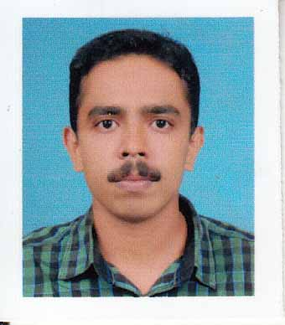  Prof. TONY SEBASTIAN
 | Designation | ASSISTANT PROFESSOR
 | Department | MATHEMATICS
 | Date of Joining the Institution | 17-06-2013
 | Qualifications with Class/Grade | BSc - FIRST CLASS MSc - FIRST CLASS
 | Total Experience in Years | Teaching – 3 Industry - NIL Research - NIL
 | Papers Published | National - NIL International - NIL
 | Papers Presented in Conferences | National- NIL International- NIL
 | PhD Guide? Give field & University | Field- NIL University- NIL
 | PhDs / Projects Guided | PhDs- NIL Projects at Masters level- NIL
 | Books Published / IPRs/ Patents | NIL
 | Professional Memberships | NIL
 | Consultancy Activities | NIL
 | Awards | NIL
 | Grants fetched | NIL
 | Interaction with Professional Institutions | NIL

13.35 | Name of Teaching Staff* | 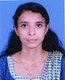  Prof. SANITHA N K
 | Designation | ASSISTANT PROFESSOR
 | Department | GEOLOGY
 | Date of Joining the Institution | 02-05-2014
 | Qualifications with Class/Grade | BSc - FIRST CLASS MSc - FIRST CLASS
 | Total Experience in Years | Teaching – 4 Industry - NIL Research - NIL
 | Papers Published | National - NIL International - NIL
 | Papers Presented in Conferences | National- NIL International- NIL
 | PhD Guide? Give field & University | Field- NIL University- NIL
 | PhDs / Projects Guided | PhDs- NIL Projects at Masters level- NIL
 | Books Published / IPRs/ Patents | NIL
 | Professional Memberships | NIL
 | Consultancy Activities | NIL
 | Awards | NIL
 | Grants fetched | NIL
 | Interaction with Professional Institutions | NIL

13.36 | Name of Teaching Staff* | 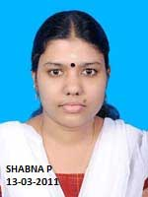  Prof. SHABNA P
 | Designation | ASSISTANT PROFESSOR
 | Department | MATHEMATICS
 | Date of Joining the Institution | 07-10-2013
 | Qualifications with Class/Grade | BSc - FIRST CLASS MSc - FIRST CLASS
 | Total Experience in Years | Teaching – 3 Industry - NIL Research - NIL
 | Papers Published | National - NIL International - NIL
 | Papers Presented in Conferences | National- NIL International- NIL
 | PhD Guide? Give field & University | Field- NIL University- NIL
 | PhDs / Projects Guided | PhDs- NIL Projects at Masters level- NIL
 | Books Published / IPRs/ Patents | NIL
 | Professional Memberships | NIL
 | Consultancy Activities | NIL
 | Awards | NIL
 | Grants fetched | NIL
 | Interaction with Professional Institutions | NIL

13.37 | Name of Teaching Staff* | 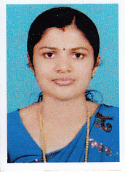  Prof. SHEENA P.
 | Designation | ASSISTANT PROFESSOR
 | Department | MATHAMATICS
 | Date of Joining the Institution | 03-09-2012
 | Qualifications with Class/Grade | BSc - FIRST CLASSS MSc - FIRST CLASS
 | Total Experience in Years | Teaching – 3 Industry -NIL Research- NIL
 | Papers Published | National- NIL International- NIL
 | Papers Presented in Conferences | National- NIL International- NIL
 | PhD Guide? Give field & University | Field- NIL University- NIL
 | PhDs / Projects Guided | PhDs- NIL Projects at Masters level- NIL
 | Books Published / IPRs/ Patents | NIL
 | Professional Memberships | NIL
 | Consultancy Activities | NIL
 | Awards | NIL
 | Grants fetched | NIL
 | Interaction with Professional Institutions | NIL

13.38 | Name of Teaching Staff* | 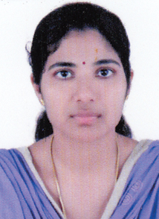  MRS. SRUTHI K
 | Designation | ASSISTANT PROFESSOR
 | Department | COMPUTER SCIENCE & ENGINEERING
 | Date of Joining the Institution | 11-07-2016
 | Qualifications with Class/Grade | B Tech - FIRST CLASS M Tech - FIRST CLASS
 | Total Experience in Years | Teaching -1 Industry- NIL Research- NIL
 | Papers Published | National- NIL International- NIL
 | Papers Presented in Conferences | National- NIL International- NIL
 | PhD Guide? Give field & University | Field- NIL University- NIL
 | PhDs / Projects Guided | PhDs- NIL Projects at Masters level- NIL
 | Books Published / IPRs/ Patents | NIL
 | Professional Memberships | NIL
 | Consultancy Activities | NIL
 | Awards | NIL
 | Grants fetched | NIL
 | Interaction with Professional Institutions | NIL

13.39 | Name of Teaching Staff* | 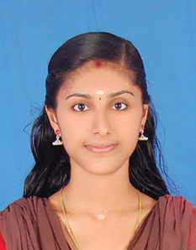  MISS. SRUTHI KP
 | Designation | ASSISTANT PROFESSOR
 | Department | PHYSICS
 | Date of Joining the Institution | 01-08-2016
 | Qualifications with Class/Grade | BSc - FIRST CLASS MSc - FIRST CLASS
 | Total Experience in Years | Teaching- 1 Industry- NIL Research- NIL
 | Papers Published | National- NIL International- NIL
 | Papers Presented in Conferences | National- NIL International- NIL
 | PhD Guide? Give field & University | Field- NIL University- NIL
 | PhDs / Projects Guided | PhDs- NIL Projects at Masters level- NIL
 | Books Published / IPRs/ Patents | NIL
 | Professional Memberships | NIL
 | Consultancy Activities | NIL
 | Awards | NIL
 | Grants fetched | NIL
 | Interaction with Professional Institutions | NIL

13.40 | Name of Teaching Staff* | 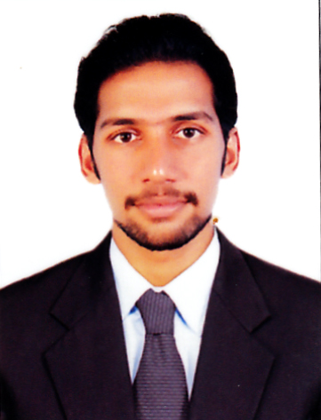  Prof. ARJUN P
 | Designation | ASSISTANT PROFESSOR
 | Department | MECHANICAL ENGINEERING
 | Date of Joining the Institution | 29-06-2015
 | Qualifications with Class/Grade | BE - FIRST CLASS MTech - FIRST CLASS
 | Total Experience in Years | Teaching- 1 Industry- NIL Research- NIL
 | Papers Published | National- NIL International- NIL
 | Papers Presented in Conferences | National- NIL International- NIL
 | PhD Guide? Give field & University | Field- NIL University- NIL
 | PhDs / Projects Guided | PhDs- NIL Projects at Masters level- NIL
 | Books Published / IPRs/ Patents | NIL
 | Professional Memberships | NIL
 | Consultancy Activities | NIL
 | Awards | NIL
 | Grants fetched | NIL
 | Interaction with Professional Institutions | NIL

13.41 | Name of Teaching Staff* | 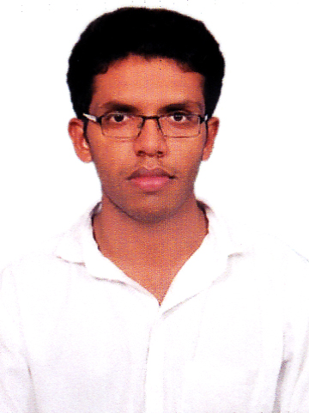  Prof. RAHUL A M
 | Designation | ASSISTANT PROFESSOR
 | Department | MECHANICAL ENGINEERING
 | Date of Joining the Institution | 22-06-2015
 | Qualifications with Class/Grade | BTech - FIRST CLASS MTech - FIRST CLASS
 | Total Experience in Years | Teaching- 1 Industry- NIL Research- NIL
 | Papers Published | National- NIL International- NIL
 | Papers Presented in Conferences | National- NIL International- NIL
 | PhD Guide? Give field & University | Field- NIL University- NIL
 | PhDs / Projects Guided | PhDs- NIL Projects at Masters level- NIL
 | Books Published / IPRs/ Patents | NIL
 | Professional Memberships | NIL
 | Consultancy Activities | NIL
 | Awards | NIL
 | Grants fetched | NIL
 | Interaction with Professional Institutions | NIL

13.42 | Name of Teaching Staff* | 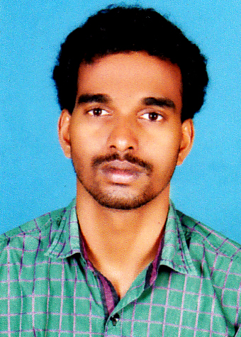  Prof. KALESH M
 | Designation | ASSISTANT PROFESSOR
 | Department | CIVIL ENGINEERING
 | Date of Joining the Institution | 06-08-2015
 | Qualifications with Class/Grade | BTech - FIRST CLASS MTech - FIRST CLASS
 | Total Experience in Years | Teaching -1 Industry - NIL Research - NIL
 | Papers Published | National - NIL International - NIL
 | Papers Presented in Conferences | National- NIL International- NIL
 | PhD Guide? Give field & University | Field- NIL University- NIL
 | PhDs / Projects Guided | PhDs- NIL Projects at Masters level- NIL
 | Books Published / IPRs/ Patents | NIL
 | Professional Memberships | NIL
 | Consultancy Activities | NIL
 | Awards | NIL
 | Grants fetched | NIL
 | Interaction with Professional Institutions | NIL

13.43 | Name of Teaching Staff* | 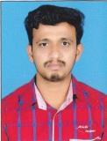  Prof. MANU C
 | Designation | ASSISTANT PROFESSOR
 | Department | ELECTRICAL & ELECTRONICS ENGG:
 | Date of Joining the Institution | 13-08-2013
 | Qualifications with Class/Grade | BTech - SECOND CLASS MTech - FIRST CLASS
 | Total Experience in Years | Teaching - 4 Industry - 3 Research - NIL
 | Papers Published | National- NIL International- NIL
 | Papers Presented in Conferences | National- NIL International- NIL
 | PhD Guide? Give field & University | Field- NIL University- NIL
 | PhDs / Projects Guided | PhDs- NIL Projects at Masters level- NIL
 | Books Published / IPRs/ Patents | NIL
 | Professional Memberships | NIL
 | Consultancy Activities | NIL
 | Awards | NIL
 | Grants fetched | NIL
 | Interaction with Professional Institutions | NIL

13.44 | Name of Teaching Staff* | 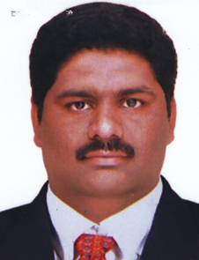  Prof. ANU JACOB PAUL
 | Designation | VICE PRINCIPAL
 | Department | MECHANICAL ENGG:
 | Date of Joining the Institution | 06-06-2016
 | Qualifications with Class/Grade | BTech - FIRST CLASS MTech - FIRST CLASS
 | Total Experience in Years | Teaching- Industry- Research- NIL
 | Papers Published | National- Nil International- Nil
 | Papers Presented in Conferences | National- Nil International- Nil
 | PhD Guide? Give field & University | Field- NIL University- NIL
 | PhDs / Projects Guided | PhDs - NIL Projects at Masters level- NIL
 | Books Published / IPRs/ Patents | Nil
 | Professional Memberships | Nil
 | Consultancy Activities | Nil
 | Awards | Nil
 | Grants fetched | Nil
 | Interaction with Professional Institutions | Nil

13.45 | Name of Teaching Staff* | 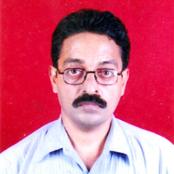  RAKESH KUMAR SHETTY
 | Designation | LECTURER
 | Department | ELECTRICAL AND ELECTRONICS ENGG:
 | Date of Joining the Institution | 01-06-2015
 | Qualifications with Class/Grade | BTech - FIRST CLASS
 | Total Experience in Years | Teaching- Industry- Research- NIL
 | Papers Published | National- Nil International- Nil
 | Papers Presented in Conferences | National- Nil International- Nil
 | PhD Guide? Give field & University | Field- NIL University- NIL
 | PhDs / Projects Guided | PhDs - NIL Projects at Masters level- NIL
 | Books Published / IPRs/ Patents | Nil
 | Professional Memberships | Nil
 | Consultancy Activities | Nil
 | Awards | Nil
 | Grants fetched | Nil
 | Interaction with Professional Institutions | Nil

13.46 | Name of Teaching Staff* | 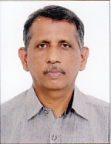  VARGHESE M SAMUEL
 | Designation | PROFESSOR
 | Department | MECHANICAL ENGG:
 | Date of Joining the Institution
 | Qualifications with Class/Grade | BTech - FIRST CLASS MTech - FIRST CLASS
 | Total Experience in Years | Teaching- Industry- Research- NIL
 | Papers Published | National- Nil International- Nil
 | Papers Presented in Conferences | National- Nil International- Nil
 | PhD Guide? Give field & University | Field- NIL University- NIL
 | PhDs / Projects Guided | PhDs - NIL Projects at Masters level- NIL
 | Books Published / IPRs/ Patents | Nil
 | Professional Memberships | Nil
 | Consultancy Activities | Nil
 | Awards | Nil
 | Grants fetched | Nil
 | Interaction with Professional Institutions | Nil

13.47 | Name of Teaching Staff* | 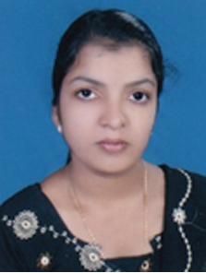  AMRUTHA KRISHNAN CP
 | Designation | LECTURER
 | Department | COMPUTER SCIENCE AND ENGINEERING:
 | Date of Joining the Institution | 11-07-2016
 | Qualifications with Class/Grade | BTech - FIRST CLASS
 | Total Experience in Years | Teaching- Industry- Research- NIL
 | Papers Published | National- Nil International- Nil
 | Papers Presented in Conferences | National- Nil International- Nil
 | PhD Guide? Give field & University | Field- NIL University- NIL
 | PhDs / Projects Guided | PhDs - NIL Projects at Masters level- NIL
 | Books Published / IPRs/ Patents | Nil
 | Professional Memberships | Nil
 | Consultancy Activities | Nil
 | Awards | Nil
 | Grants fetched | Nil
 | Interaction with Professional Institutions | Nil

13.48 | Name of Teaching Staff* | 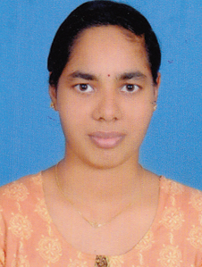  SRUTHI T
 | Designation | LECTURER
 | Department | COMPUTER SCIENCE AND ENGINEERING:
 | Date of Joining the Institution | 11-07-2016
 | Qualifications with Class/Grade | BTech - FIRST CLASS
 | Total Experience in Years | Teaching- Industry- Research- NIL
 | Papers Published | National- Nil International- Nil
 | Papers Presented in Conferences | National- Nil International- Nil
 | PhD Guide? Give field & University | Field- NIL University- NIL
 | PhDs / Projects Guided | PhDs - NIL Projects at Masters level- NIL
 | Books Published / IPRs/ Patents | Nil
 | Professional Memberships | Nil
 | Consultancy Activities | Nil
 | Awards | Nil
 | Grants fetched | Nil
 | Interaction with Professional Institutions | Nil

13.49 | Name of Teaching Staff* | 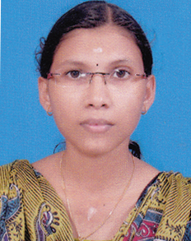  ANUPAMA C
 | Designation | LECTURER
 | Department | CIVIL ENGINEERING:
 | Date of Joining the Institution | 27-06-2016
 | Qualifications with Class/Grade | BTech - FIRST CLASS
 | Total Experience in Years | Teaching- Industry- Research- NIL
 | Papers Published | National- Nil International- Nil
 | Papers Presented in Conferences | National- Nil International- Nil
 | PhD Guide? Give field & University | Field- NIL University- NIL
 | PhDs / Projects Guided | PhDs - NIL Projects at Masters level- NIL
 | Books Published / IPRs/ Patents | Nil
 | Professional Memberships | Nil
 | Consultancy Activities | Nil
 | Awards | Nil
 | Grants fetched | Nil
 | Interaction with Professional Institutions | Nil

13.50 | Name of Teaching Staff* | 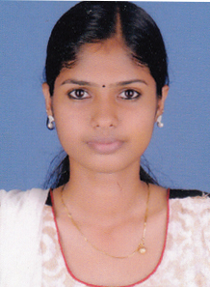  CHITHRA P
 | Designation | LECTURER
 | Department | CIVIL ENGINEERING:
 | Date of Joining the Institution | 11-07-2016
 | Qualifications with Class/Grade | BTech - FIRST CLASS
 | Total Experience in Years | Teaching- Industry- Research- NIL
 | Papers Published | National- Nil International- Nil
 | Papers Presented in Conferences | National- Nil International- Nil
 | PhD Guide? Give field & University | Field- NIL University- NIL
 | PhDs / Projects Guided | PhDs - NIL Projects at Masters level- NIL
 | Books Published / IPRs/ Patents | Nil
 | Professional Memberships | Nil
 | Consultancy Activities | Nil
 | Awards | Nil
 | Grants fetched | Nil
 | Interaction with Professional Institutions | Nil

13.51 | Name of Teaching Staff* | 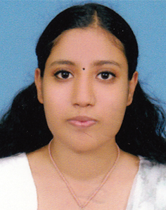  POORNIMA MOHAN P
 | Designation | LECTURER
 | Department | ELECTRONICS & COMMUNICATION ENGG:
 | Date of Joining the Institution | 11-07-2016
 | Qualifications with Class/Grade | BTech - FIRST CLASS
 | Total Experience in Years | Teaching- Industry- Research- NIL
 | Papers Published | National- Nil International- Nil
 | Papers Presented in Conferences | National- Nil International- Nil
 | PhD Guide? Give field & University | Field- NIL University- NIL
 | PhDs / Projects Guided | PhDs - NIL Projects at Masters level- NIL
 | Books Published / IPRs/ Patents | Nil
 | Professional Memberships | Nil
 | Consultancy Activities | Nil
 | Awards | Nil
 | Grants fetched | Nil
 | Interaction with Professional Institutions | Nil

13.52 | Name of Teaching Staff* | 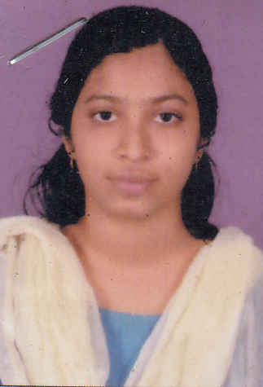  ANCY PV
 | Designation | ASSISTANT PROFESSOR
 | Department | ELECTRONICS & COMMUNICATION ENGG:
 | Date of Joining the Institution | 22-09-2016
 | Qualifications with Class/Grade | B Tech - FIRST CLASS M Tech - FIRST CLASS
 | Total Experience in Years | Teaching- Industry- Research- NIL
 | Papers Published | National- Nil International- Nil
 | Papers Presented in Conferences | National- Nil International- Nil
 | PhD Guide? Give field & University | Field- NIL University- NIL
 | PhDs / Projects Guided | PhDs - NIL Projects at Masters level- NIL
 | Books Published / IPRs/ Patents | Nil
 | Professional Memberships | Nil
 | Consultancy Activities | Nil
 | Awards | Nil
 | Grants fetched | Nil
 | Interaction with Professional Institutions | Nil

13.53 | Name of Teaching Staff* | 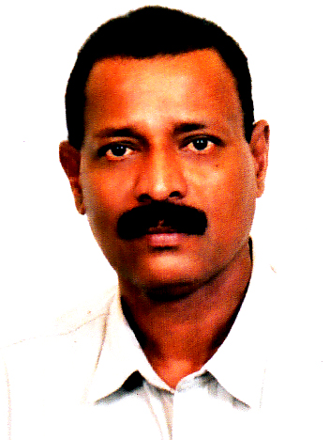  SASIDHARAN H V
 | Designation | ASSISTANT PROFESSOR
 | Department | PHYSICAL EDUCATION:
 | Date of Joining the Institution | 01-06-2015
 | Qualifications with Class/Grade | M Phil
 | Total Experience in Years | Teaching- Industry- Research- NIL
 | Papers Published | National- Nil International- Nil
 | Papers Presented in Conferences | National- Nil International- Nil
 | PhD Guide? Give field & University | Field- NIL University- NIL
 | PhDs / Projects Guided | PhDs - NIL Projects at Masters level- NIL
 | Books Published / IPRs/ Patents | Nil
 | Professional Memberships | Nil
 | Consultancy Activities | Nil
 | Awards | Nil
 | Grants fetched | Nil
 | Interaction with Professional Institutions | Nil

13.54 | Name of Teaching Staff* | 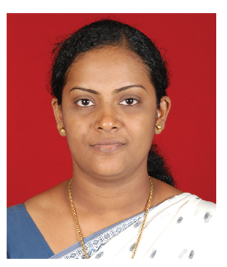  PRIYA ACHAMMA JACOB
 | Designation | ASSOSIATE PROFESSOR
 | Department | CIVIL ENGG:
 | Date of Joining the Institution | 03-10-2016
 | Qualifications with Class/Grade | M Tech - FIRST CLASS Phd
 | Total Experience in Years | Teaching- Industry- Research- NIL
 | Papers Published | National- Nil International- Nil
 | Papers Presented in Conferences | National- Nil International- Nil
 | PhD Guide? Give field & University | Field- NIL University- NIL
 | PhDs / Projects Guided | PhDs - NIL Projects at Masters level- NIL
 | Books Published / IPRs/ Patents | Nil
 | Professional Memberships | Nil
 | Consultancy Activities | Nil
 | Awards | Nil
 | Grants fetched | Nil
 | Interaction with Professional Institutions | Nil

13.61 | Name of Teaching Staff* | 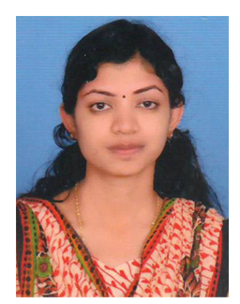  SUKINA K
 | Designation | ASSISTANT PROFESSOR
 | Department | COMPUTER SCIENCE & ENGG:
 | Date of Joining the Institution | 16-01-2017
 | Qualifications with Class/Grade | B Tech - FIRST CLASS M Tech - FIRST CLASS
 | Total Experience in Years | Teaching- Industry- Research- NIL
 | Papers Published | National- Nil International- Nil
 | Papers Presented in Conferences | National- Nil International- Nil
 | PhD Guide? Give field & University | Field- NIL University- NIL
 | PhDs / Projects Guided | PhDs - NIL Projects at Masters level- NIL
 | Books Published / IPRs/ Patents | Nil
 | Professional Memberships | Nil
 | Consultancy Activities | Nil
 | Awards | Nil
 | Grants fetched | Nil
 | Interaction with Professional Institutions | Nil

13.61 | Name of Teaching Staff* | 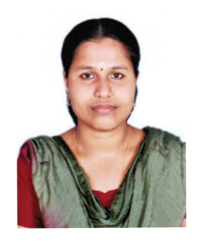  MEERA M
 | Designation | ASSISTANT PROFESSOR
 | Department | ELECTRONICS & COMMUNICATION ENGG:
 | Date of Joining the Institution | 16-01-2017
 | Qualifications with Class/Grade | B Tech - FIRST CLASS M Tech - FIRST CLASS
 | Total Experience in Years | Teaching- Industry- Research- NIL
 | Papers Published | National- Nil International- Nil
 | Papers Presented in Conferences | National- Nil International- Nil
 | PhD Guide? Give field & University | Field- NIL University- NIL
 | PhDs / Projects Guided | PhDs - NIL Projects at Masters level- NIL
 | Books Published / IPRs/ Patents | Nil
 | Professional Memberships | Nil
 | Consultancy Activities | Nil
 | Awards | Nil
 | Grants fetched | Nil
 | Interaction with Professional Institutions | Nil

14 | Admission quota* | Government quota & Management Quota
 | Entrance test / admission criteria | Entrance Test conducted by Govt of Kerala (CEE)
 | Cut off / last candidate admitted | CAY & CAY-1 50% for Mathematics & 50% for PCM put together
 | Fees in rupees | Govt Quota Rs.40,000/- and Rs.65,000/- Management Quota Rs. 75,000/-
 | Number of Fee Waivers offered | CAY 0 CAY-1 0 CAY-2 0
 | Admission Calendar | From May/July Every year
 | PIO quota | No
15 | Infrastructural information
 | Classroom/Tutorial Room facilities | FOR PHOTOGRAPHS, PLEASE SEE ANNEXURE NO-4
 | Laboratory details | LABORATORIES ARE AVAILABLE AS PER KANNUR UNIVERSITY SYLLABUS -SEE ANNEXURE NO -5
 | Computer Centre facilities | 160 Systems with Intel Core I3 Processor, DDR-3, 2 GB Zion RAM, 500 GB HARD DISK, 17” Dell LCD Monitor -All Systems are connected with LAN-Reliance 2 mbps Contention ratio 1:1 Internet is available
 | Library facilities | SEE ANNEXURE NO-4
 | Auditorium / Seminar Halls / Amphi | Available
 | Cafeteria | Available
 | Indoor Sports facilities | Available
 | Outdoor Sports facilities | Available
 | Gymnasium facilities | Available
 | Facilities for disabled | Available
 | Any other facilities | STD Booth, Bus services, Hostels etc
16 | Boys Hostel | Rented building-Permanent building under construction
 | Girls Hostel | Rented building-Permanent building under construction
 | Medical & other Facilities at Hostel | Medical facility available
17 | Academic Sessions
 | Examination system, Year / Sem | Semester
 | Period of declaration of results | As per University notification
18 | Counseling / Mentoring
 | Career Counseling | Career Counseling facilities are available.
 | Medical facilities | Available with Part Time Medical Officer
 | Student Insurance | Available

19 | Students Activity Body
 | Cultural activities | Available
 | Sports activities | Available
 | Literary activities | Available
 | Magazine / Newsletter | Available
 | Technical activities / Tech-Fest | Available
 | Industrial Visits / Tours | Available
 | Alumni activities | First year of operation, yet to start
20 | Name of the Information Officer for RTI | MR. JACOB JOHN
 | Designation | Director
 | Phone number with STD code | 0467-2440024
 | FAX number with STD code | 04985-205907
 | Email | director@nmitkerala.ac.in

Annexure No-1
BOARD OF GOVERNORS
S.NO | NAME | DESIGNATION | Represented by
1 | Dr Gangan Prathap | Chairman | Trust
2 | K. P. Balakrishnan | Member | Trust
3 | Jacob John | Member | Trust
4 | K. P. Ganeshan | Member | Trust
5 | K. V. Ravindran | Member | Trust
6 |  | Member | Nominee of AICTE
7 | Dr K Rajagopal | Member | Industrialist
8 |  | Member | University
9 |  | Member | State Govt
10 |  | Member | Technologist nominated by State Govt.
11 | Dr. Suresan Pareth | Member Secretary | Principal

Annexure No.2

ACADEMIC ADVISORY BODY

Dr Gangan Prathap
Dr K Rajagopal
Dr Vinod Veedu
Dr Harinder Singh Jagdev
K V Ravindran
Prof T P Radhakrishnan
C R Nambiar

Annexure No.3
Organizational Structure
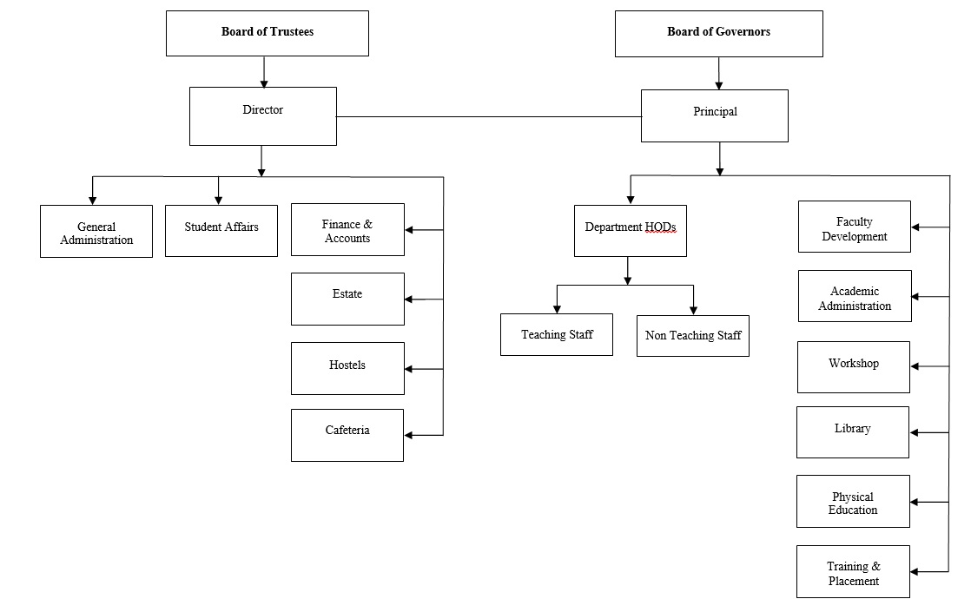

Annexure No.4

 | Classroom | 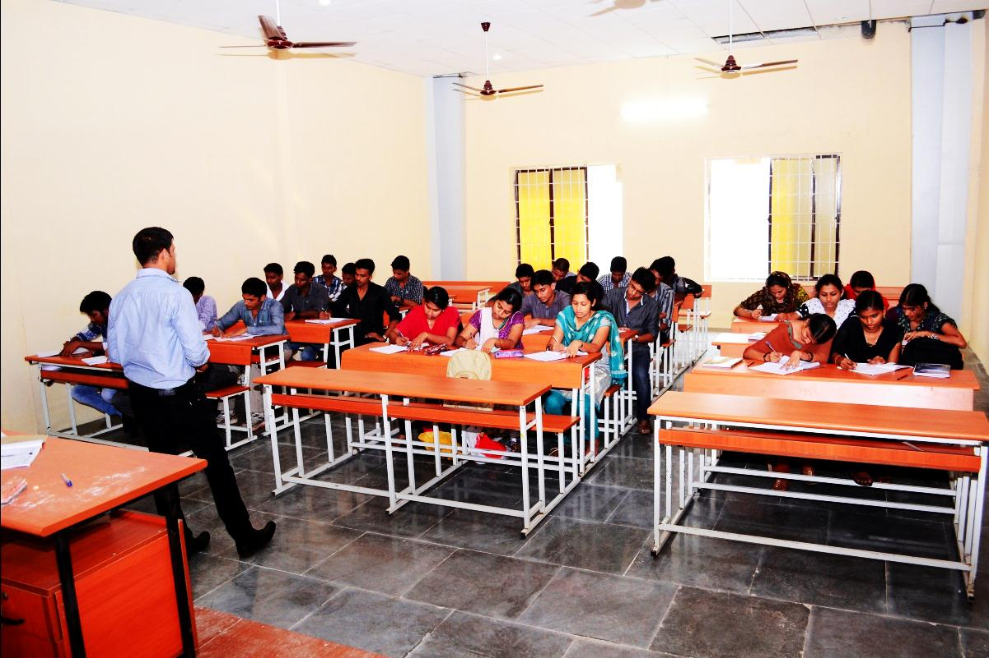
 | Tutorial Room facilities | 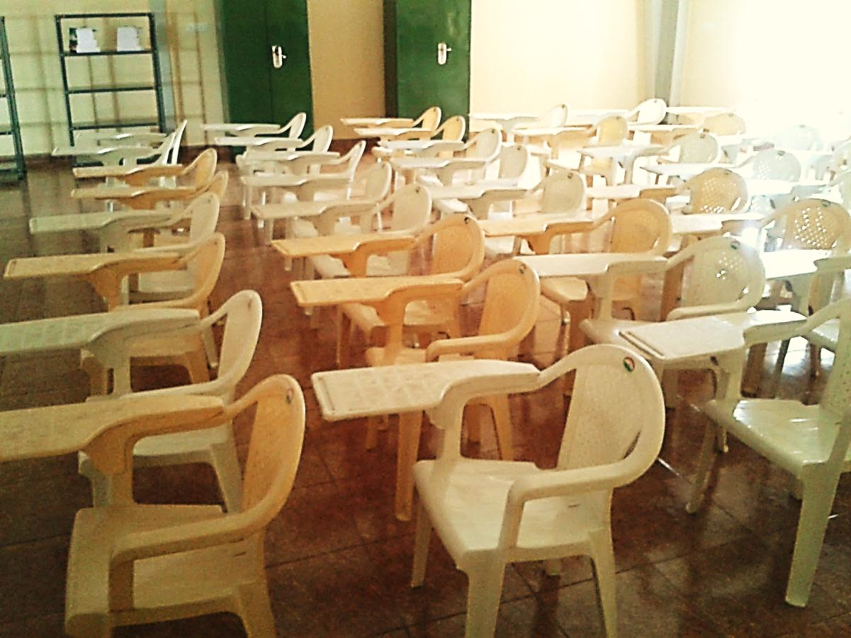

 | Workshop -1 | 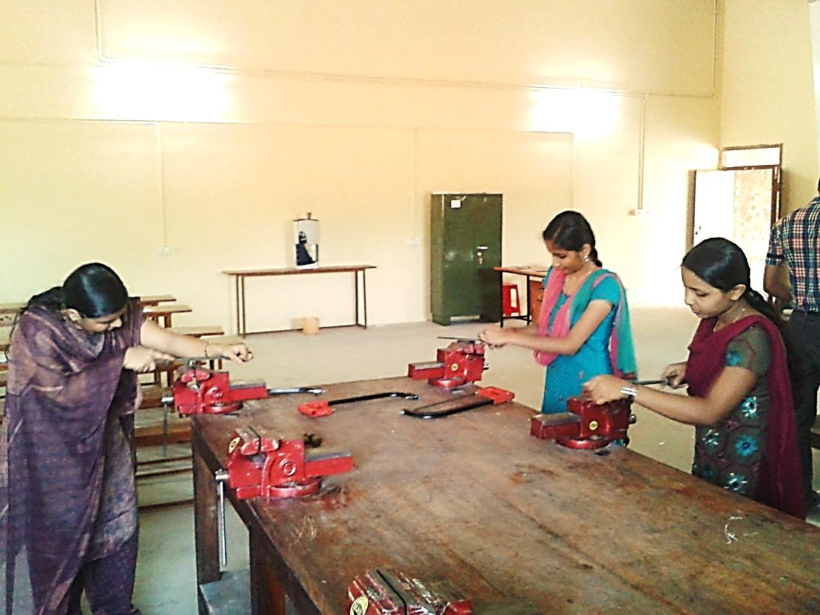
 | Workshop -2 | 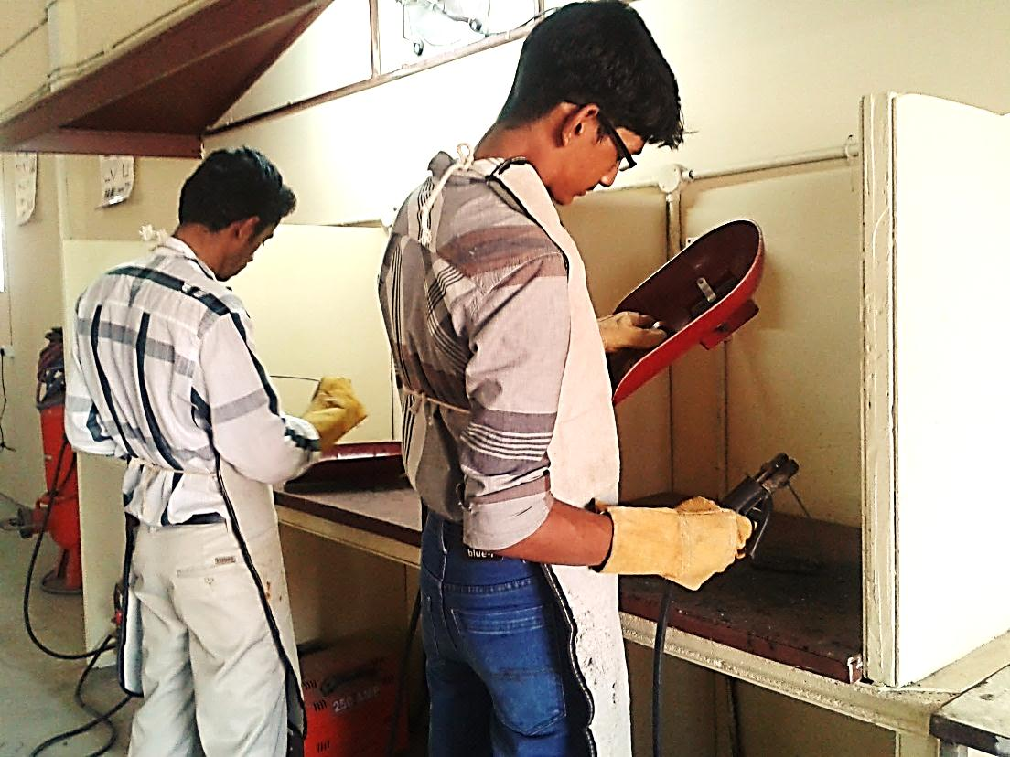

 | Electronics lab | 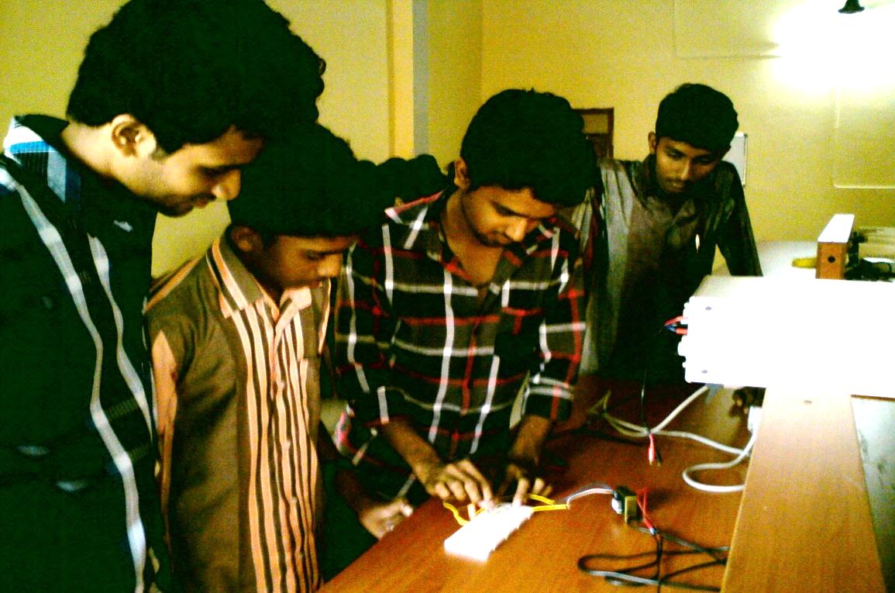

 | Electrical Lab | 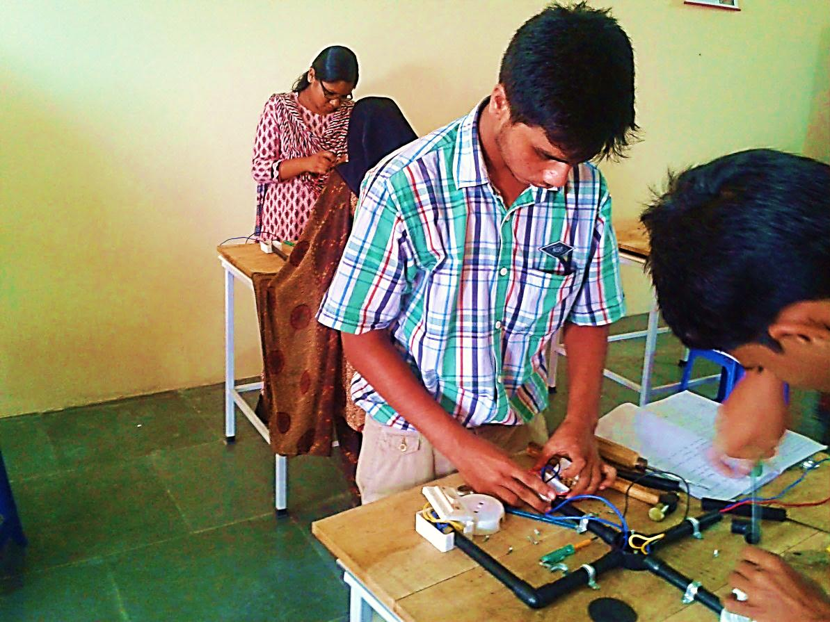
 | Mechanical LAB-1 | 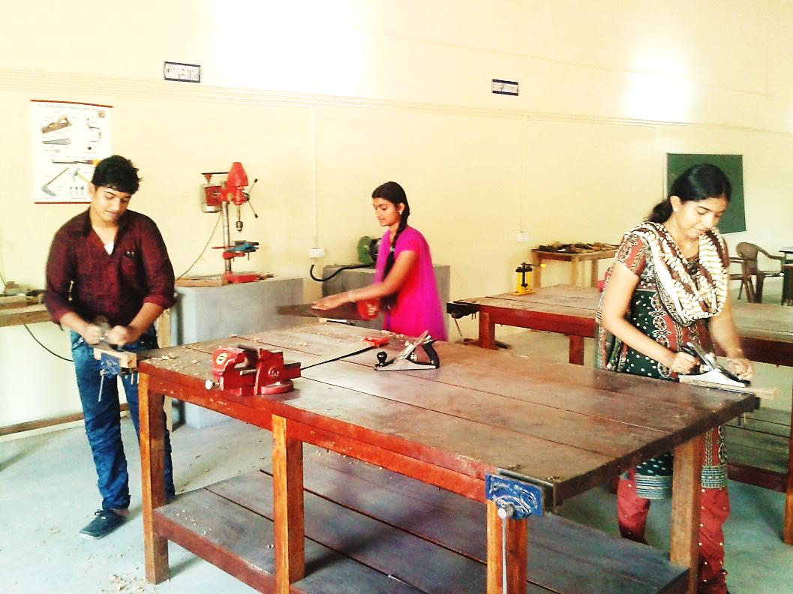
 | Mechanical LAB-2 | 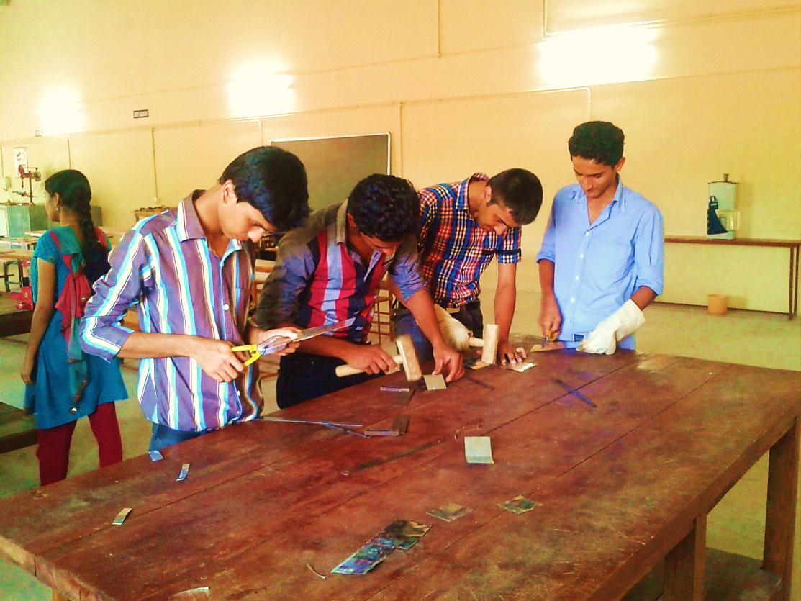

 | Computer Centre facilities | 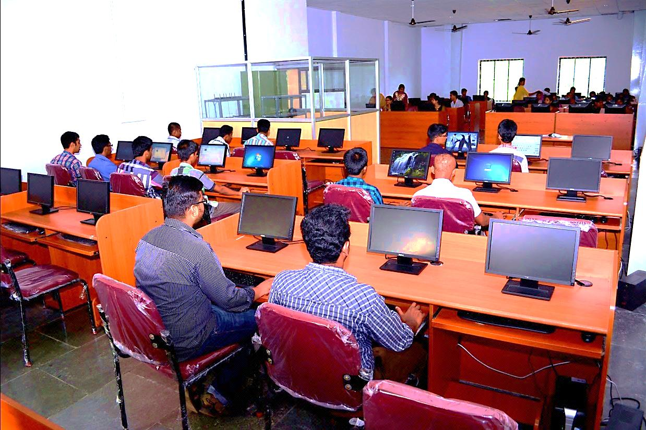
 | Language Lab facilities | 