 | MANDATORY DISCLOSURE
 | Mandatory Disclosure | updated on 30.01.2018
1 | AICTE File No. | South-West/1-3326965633/2017/EOA
 | Date & Period of last approval | 10.04.2017 Period 2017-18
2 | Name of the Institution | NORTH MALABAR INSTITUTE OF TECHNOLOGY
 | Address of the Institution | NELLIYADUKAM
 |  | PARKALAI
 |  | KANHANGAD
 | City & Pin Code | KASARGODE - 671531
 | State / UT | KERALA
 | Phone number with STD code | 0467-2440024
 | FAX number with STD Code | 0467-2244806
 | Office hours at the Institution | 9 AM TO 5.00 PM
 | Academic hours at the Institution | 9.00 AM TO 4.00 PM
 | Email | info@nmitkerala.ac.in
 | Website | www.nmitkerala.ac.in

 | Nearest Railway Station (dist in Km) | Kanhangad - 9 KMS
 | Nearest Airport (dist in Km) | Mangalore - 100 KMS
3 | Type of Institution | Private-Self Financed
 | Category (1) of the Institution | Non Minority
 | Category (2) of the Institution | Co-Ed
4 | Name of the organization running the Institution | North Malabar Educational & Charitable Trust
 | Type of the organization | Public Charitable Trust
 | Address of the organization | 20 – D1 & D5, Municipal Office Building
 |  | Payyanur, Kannur District.
 | Registered with | Sub Registrar’s Office, Payyanur
 | Registration date | 04/09/2008
 | Website of the organization | www.nmitkerala.ac.in
5 | Name of the affiliating University / Board | APJ ABDUL KALAM TECHNOLOGICAL UNIVERSITY
 | Address | CET CAMPUS, THIRUVANANTHAPURAM-695016
 | Website | www.ktu.edu.in
 | Latest affiliation period | 2017-18
6 | Name of Principal / Director | Er. JACOB JOHN
 | Exact Designation | DIRECTOR
 | Phone number with STD code | 0467-2440024, 0467-2244802
 | FAX number with STD code | 0467-2244806
 | Email | director@nmitkerala.ac.in
 | Highest Degree | B.Tech, FIE
 | Field of specialization | Mechanical Engineering
7 | Governing Board Members | See Annexure No.1
 | Frequency of meetings & date of last meeting | Twice in a year -20.12.2017
8 | Academic Advisory Body | See Annexure No.2
 | Frequency of meetings & date of last meeting | Twice in a year-20.12.2017
9 | Organizational Chart | See Annexure No.3
10 | Student feedback mechanism Institutional Governance/faculty performance | We have devised a feedback system for getting students opinion on faculty performance and institutional governance. Proper follow up action will be taken to correct the anomalies if any. Class committee has been formed to provide periodic feedback.
11 | Grievance redressal mechanism for faculty, staff and students | Compliance and Redressal committee is functioning in our college. Grievances are thoroughly discussed by the Committee and remedial measures are implemented.

12.1 | Name of the Department* | CIVIL ENGINEERING
 | Course | B.TECH. CIVIL ENGINEERING
 | Level | UG /DEGREE
 | 1st Year of approval by the Council | 2012-13
 | Year wise Sanctioned Intake | CAY1 60 CAY2 60 CAY3 60 CAY4 60
 | Year wise Actual Admissions | CAY1 40 CAY2 26 CAY3 47 CAY4 61
 | Cut off marks –General quota | 50% for Mathematics &50% P+C+M
 | % Students passed with Distinction | NA
 | % Students passed with First Class | NA
 | Students Placed | NA
 | Average Pay package, Rs./Year | NA
 | Students opted for Higher Studies | NA
 | Accreditation Status of the course | Not Accredited
 | Doctoral Courses | No
 | Foreign Collaborations, if any | No
 | Professional Society Memberships | Yet to start
 | Professional activities | Yet to start
 | Consultancy activities | No
 | Grants fetched | No
 | Departmental Achievements
 | Distinguished Alumni | No

12.2 | Name of the Department* | MECHANICAL ENGINEERING
 | Course | B.TECH MECHANICAL ENGINEERING
 | Level | UG /DEGREE
 | 1st Year of approval by the Council | 2012-13
 | Year wise Sanctioned Intake | CAY1 60 CAY2 60 CAY3 60 CAY4 60
 | Year wise Actual Admissions | CAY1 19 CAY2 34 CAY3 56 CAY4 71
 | Cut off marks –General quota | 50% for Mathematics & 50% P+C+M
 | % Students passed with Distinction | NA
 | % Students passed with First Class | NA
 | Students Placed | NA
 | Average Pay package, Rs./Year | NA
 | Students opted for Higher Studies | NA
 | Accreditation Status of the course | Not Accredited
 | Doctoral Courses | No
 | Foreign Collaborations, if any | No
 | Professional Society Memberships | Yet to start
 | Professional activities | Yet to start
 | Consultancy activities | No
 | Grants fetched | No
 | Departmental Achievements
 | Distinguished Alumni | No

12.3 | Name of the Department* | ELECTRONICS & COMMUNICATION ENGINEERING
 | Course | B.TECH. ELECTRONICS & COMMUNICATION ENGINEERING
 | Level | UG /DEGREE
 | 1st Year of approval by the Council | 2012-13
 | Year wise Sanctioned Intake | CAY1 60 CAY2 60 CAY3 60 CAY4 60
 | Year wise Actual Admissions | CAY1 5 CAY2 14 CAY3 31 CAY4 31
 | Cut off marks –General quota | 50% for Mathematics & 50% P+C+M
 | % Students passed with Distinction | NA
 | % Students passed with First Class | NA
 | Students Placed | NA
 | Average Pay package, Rs./Year | NA
 | Students opted for Higher Studies | NA
 | Accreditation Status of the course | Not Accredited
 | Doctoral Courses | No
 | Foreign Collaborations, if any | No
 | Professional Society Memberships | Yet to start
 | Professional activities | Yet to start
 | Consultancy activities | No
 | Grants fetched | No
 | Departmental Achievements
 | Distinguished Alumni | No

12.4 | Name of the Department* | ELECTRICAL AND ELECTRONICS ENGINEERING
 | Course | B.TECH. ELECTRICAL & ELECTRONICS ENGINEERING
 | Level | UG /DEGREE
 | 1st Year of approval by the Council | 2012-13
 | Year wise Sanctioned Intake | CAY 60 CAY 60 CAY 60 CAY 60
 | Year wise Actual Admissions | CAY 4 CAY 8 CAY 10 CAY 19
 | Cut off marks –General quota | 50% for Mathematics & 50% P+C+M
 | % Students passed with Distinction | NA
 | % Students passed with First Class | NA
 | Students Placed | NA
 | Average Pay package, Rs./Year | NA
 | Students opted for Higher Studies | NA
 | Accreditation Status of the course | Not Accredited
 | Doctoral Courses | No
 | Foreign Collaborations, if any | No
 | Professional Society Memberships | Yet to start
 | Professional activities | Yet to start
 | Consultancy activities | No
 | Grants fetched | No
 | Departmental Achievements
 | Distinguished Alumni | No

12.5 | Name of the Department* | COMPUTER SCIENCE & ENGINEERING
 | Course | B.TECH. COMPUTER SCIENCE & ENGINEERING
 | Level | UG /DEGREE
 | 1st Year of approval by the Council | 2012-13
 | Year wise Sanctioned Intake | CAY 60 CAY 60 CAY 60 CAY 60
 | Year wise Actual Admissions | CAY 23 CAY 24 CAY 54 CAY 60
 | Cut off marks –General quota | 50% for Mathematics & 50% P+C+M
 | % Students passed with Distinction | NA
 | % Students passed with First Class | NA
 | Students Placed | NA
 | Average Pay package, Rs./Year | NA
 | Students opted for Higher Studies | NA
 | Accreditation Status of the course | Not Accredited
 | Doctoral Courses | No
 | Foreign Collaborations, if any | No
 | Professional Society Memberships | Yet to start
 | Professional activities | Yet to start
 | Consultancy activities | No
 | Grants fetched | No
 | Departmental Achievements
 | Distinguished Alumni | No

13.1 | Name of Teaching Staff* | 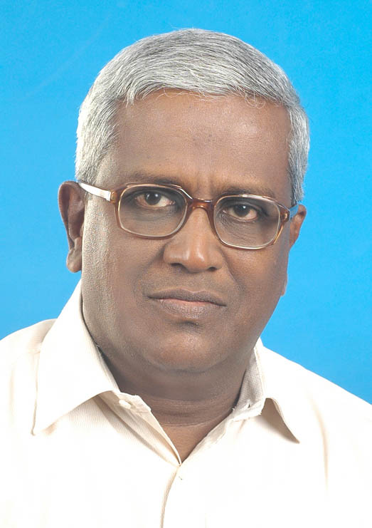  Prof. JACOB JOHN
 | Designation | ASSOCIATE PROFESSOR / DIRECTOR
 | Department | MECHANICAL ENGINEERING
 | Date of Joining the Institution | 01-09-2012
 | Qualifications with Class/Grade | B.Tech- FIRST CLASS FIE
 | Total Experience in Years | Teaching - 20 Industry - 18 Research - NIL
 | Papers Published | National - NIL International - NIL
 | Papers Presented in Conferences | National- NIL International- NIL
 | PhD Guide? Give field & University | Field- NIL University- NIL
 | PhDs / Projects Guided | PhDs- NIL Projects at Masters level- NIL
 | Books Published / IPRs/ Patents | NIL
 | Professional Memberships | NIL
 | Consultancy Activities | NIL
 | Awards | NIL
 | Grants fetched | NIL
 | Interaction with Professional Institutions | NIL

13.2 | Name of Teaching Staff* | 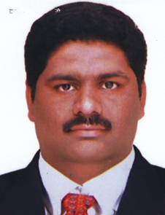  Prof. ANU JACOB PAUL
 | Designation | PRINCIPAL INCHARGE/PROFESSOR
 | Department | MECHANICAL ENGG:
 | Date of Joining the Institution | 06-06-2016
 | Qualifications with Class/Grade | BTech - FIRST CLASS MTech - FIRST CLASS
 | Total Experience in Years | Teaching- Industry- Research- NIL
 | Papers Published | National- Nil International- Nil
 | Papers Presented in Conferences | National- Nil International- Nil
 | PhD Guide? Give field & University | Field- NIL University- NIL
 | PhDs / Projects Guided | PhDs - NIL Projects at Masters level- NIL
 | Books Published / IPRs/ Patents | Nil
 | Professional Memberships | Nil
 | Consultancy Activities | Nil
 | Awards | Nil
 | Grants fetched | Nil
 | Interaction with Professional Institutions | Nil

13.3 | Name of Teaching Staff* | 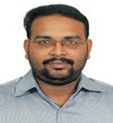  Dr. VIJEESH VIJAYAN
 | Designation | PRINCIPAL INCHARGE/PROFESSOR
 | Department | MECHANICAL ENGINEERING
 | Date of Joining the Institution | 19-07-2017
 | Qualifications with Class/Grade | B. Tech - FIRST CLASS M. Tech- FIRST CLASS  Phd
 | Total Experience in Years | Teaching- 06 Industry- Research- 04
 | Papers Published | National- 01 International- 17
 | Papers Presented in Conferences | National- Nil International- Nil
 | PhD Guide? Give field & University | Field- NIL University- NIL
 | PhDs / Projects Guided | PhDs - NIL Projects at Masters level- NIL
 | Books Published / IPRs/ Patents | Nil
 | Professional Memberships | Nil
 | Consultancy Activities | Nil
 | Awards | Nil
 | Grants fetched | Nil
 | Interaction with Professional Institutions | Nil

13.4 | Name of Teaching Staff* | 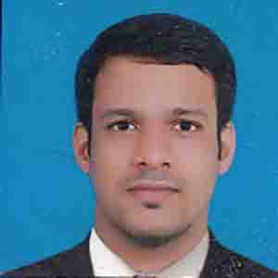  Prof. RANJITH T. V.
 | Designation | ASSISTANT PROFESSOR
 | Department | MECHANICAL ENGINEERING
 | Date of Joining the Institution | 01-09-2012
 | Qualifications with Class/Grade | BTech - FIRST CLASS MTech - FIRST CLASS
 | Total Experience in Years | Teaching- 5 Industry- NIL Research- NIL
 | Papers Published | National- NIL International- NIL
 | Papers Presented in Conferences | National- NIL International- NIL
 | PhD Guide? Give field & University | Field- NIL University- NIL
 | PhDs / Projects Guided | PhDs- NIL Projects at Masters level- NIL
 | Books Published / IPRs/ Patents | NIL
 | Professional Memberships | NIL
 | Consultancy Activities | NIL
 | Awards | NIL
 | Grants fetched | NIL
 | Interaction with Professional Institutions | NIL

13.5 | Name of Teaching Staff* | 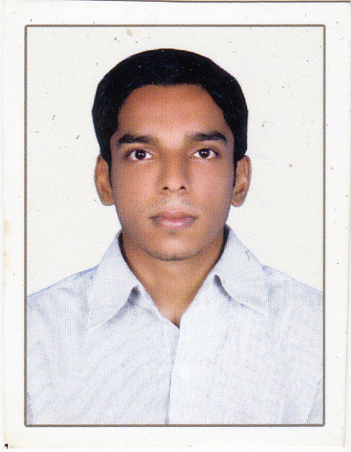  Prof. JIJITH P K
 | Designation | ASSISTANT PROFESSOR
 | Department | MECHANICAL ENGINEERING
 | Date of Joining the Institution | 16-06-2014
 | Qualifications with Class/Grade | BTech - FIRST CLASS MTech - FIRST CLASS
 | Total Experience in Years | Teaching- 3 Industry- NIL Research- NIL
 | Papers Published | National- NIL International- NIL
 | Papers Presented in Conferences | National- NIL International- NIL
 | PhD Guide? Give field & University | Field- NIL University- NIL
 | PhDs / Projects Guided | PhDs- NIL Projects at Masters level- NIL
 | Books Published / IPRs/ Patents | NIL
 | Professional Memberships | NIL
 | Consultancy Activities | NIL
 | Awards | NIL
 | Grants fetched | NIL
 | Interaction with Professional Institutions | NIL

13.6 | Name of Teaching Staff* | 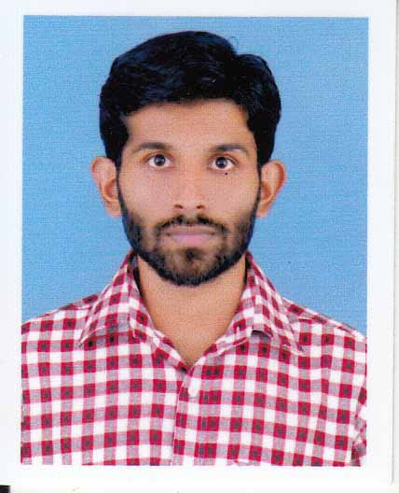  Prof. JUBIN JAMES
 | Designation | ASSISTANT PROFESSOR
 | Department | MECHANICAL ENGINEERING
 | Date of Joining the Institution | 01-09-2013
 | Qualifications with Class/Grade | BTech - FIRST CLASS MTech - FIRST CLASS
 | Total Experience in Years | Teaching- 4 Industry- NIL Research- NIL
 | Papers Published | National- NIL International- NIL
 | Papers Presented in Conferences | National- NIL International- NIL
 | PhD Guide? Give field & University | Field- NIL University- NIL
 | PhDs / Projects Guided | PhDs- NIL Projects at Masters level- NIL
 | Books Published / IPRs/ Patents | NIL
 | Professional Memberships | NIL
 | Consultancy Activities | NIL
 | Awards | NIL
 | Grants fetched | NIL
 | Interaction with Professional Institutions | NIL

13.7 | Name of Teaching Staff* | 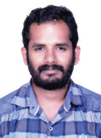  Prof. BINESH BALAN
 | Designation | ASSISTANT PROFESSOR
 | Department | MECHANICAL ENGINEERING
 | Date of Joining the Institution | 01-01-2018
 | Qualifications with Class/Grade | BTech - FIRST CLASS MTech - FIRST CLASS
 | Total Experience in Years | Teaching- NIL Industry- NIL Research- NIL
 | Papers Published | National- NIL International- NIL
 | Papers Presented in Conferences | National- NIL International- NIL
 | PhD Guide? Give field & University | Field- NIL University- NIL
 | PhDs / Projects Guided | PhDs- NIL Projects at Masters level- NIL
 | Books Published / IPRs/ Patents | NIL
 | Professional Memberships | NIL
 | Consultancy Activities | NIL
 | Awards | NIL
 | Grants fetched | NIL
 | Interaction with Professional Institutions | NIL

13.8 | Name of Teaching Staff* | 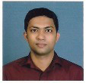  Prof. RAJEESH P
 | Designation | ASSISTANT PROFESSOR
 | Department | MECHANICAL ENGINEERING
 | Date of Joining the Institution | 02-05-2014
 | Qualifications with Class/Grade | BTech - FIRST CLASS MTech - FIRST CLASS
 | Total Experience in Years | Teaching- 2 Industry- 1 Research- NIL
 | Papers Published | National- NIL International- NIL
 | Papers Presented in Conferences | National- NIL International- NIL
 | PhD Guide? Give field & University | Field- NIL University- NIL
 | PhDs / Projects Guided | PhDs- NIL Projects at Masters level- NIL
 | Books Published / IPRs/ Patents | NIL
 | Professional Memberships | NIL
 | Consultancy Activities | NIL
 | Awards | NIL
 | Grants fetched | NIL
 | Interaction with Professional Institutions | NIL

13.9 | Name of Teaching Staff* | 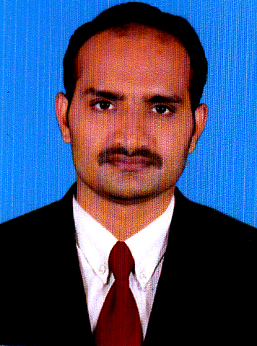  Prof. VISHNU PRASAD
 | Designation | ASSISTANT PROFESSOR
 | Department | MECHANICAL ENGINEERING
 | Date of Joining the Institution | 25-01-2016
 | Qualifications with Class/Grade | BTech - FIRST CLASS MTech - FIRST CLASS
 | Total Experience in Years | Teaching- 2 Industry- Research- NIL
 | Papers Published | National- NIL International- NIL
 | Papers Presented in Conferences | National- NIL International- NIL
 | PhD Guide? Give field & University | Field- NIL University- NIL
 | PhDs / Projects Guided | PhDs- NIL Projects at Masters level- NIL
 | Books Published / IPRs/ Patents | NIL
 | Professional Memberships | NIL
 | Consultancy Activities | NIL
 | Awards | NIL
 | Grants fetched | NIL
 | Interaction with Professional Institutions | NIL

13.10 | Name of Teaching Staff* | 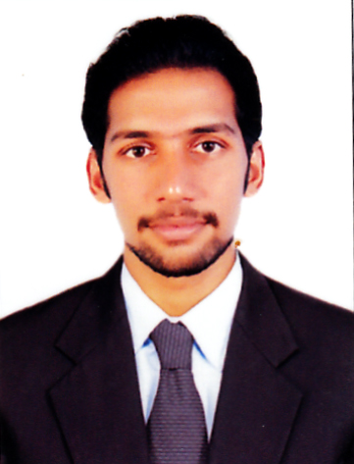  Prof. ARJUN P
 | Designation | ASSISTANT PROFESSOR
 | Department | MECHANICAL ENGINEERING
 | Date of Joining the Institution | 29-06-2015
 | Qualifications with Class/Grade | BE - FIRST CLASS MTech - FIRST CLASS
 | Total Experience in Years | Teaching- 1 Industry- NIL Research- NIL
 | Papers Published | National- NIL International- NIL
 | Papers Presented in Conferences | National- NIL International- NIL
 | PhD Guide? Give field & University | Field- NIL University- NIL
 | PhDs / Projects Guided | PhDs- NIL Projects at Masters level- NIL
 | Books Published / IPRs/ Patents | NIL
 | Professional Memberships | NIL
 | Consultancy Activities | NIL
 | Awards | NIL
 | Grants fetched | NIL
 | Interaction with Professional Institutions | NIL

13.11 | Name of Teaching Staff* | 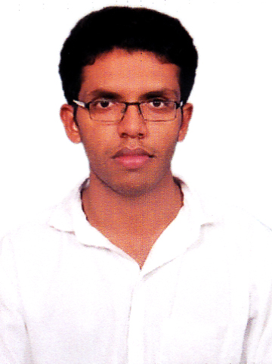  Prof. RAHUL A M
 | Designation | ASSISTANT PROFESSOR
 | Department | MECHANICAL ENGINEERING
 | Date of Joining the Institution | 22-06-2015
 | Qualifications with Class/Grade | BTech - FIRST CLASS MTech - FIRST CLASS
 | Total Experience in Years | Teaching- 1 Industry- NIL Research- NIL
 | Papers Published | National- NIL International- NIL
 | Papers Presented in Conferences | National- NIL International- NIL
 | PhD Guide? Give field & University | Field- NIL University- NIL
 | PhDs / Projects Guided | PhDs- NIL Projects at Masters level- NIL
 | Books Published / IPRs/ Patents | NIL
 | Professional Memberships | NIL
 | Consultancy Activities | NIL
 | Awards | NIL
 | Grants fetched | NIL
 | Interaction with Professional Institutions | NIL

13.12 | Name of Teaching Staff* | 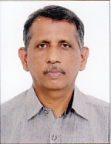  VARGHESE M SAMUEL
 | Designation | PROFESSOR
 | Department | MECHANICAL ENGG:
 | Date of Joining the Institution
 | Qualifications with Class/Grade | BTech - FIRST CLASS MTech - FIRST CLASS
 | Total Experience in Years | Teaching- Industry- Research- NIL
 | Papers Published | National- Nil International- Nil
 | Papers Presented in Conferences | National- Nil International- Nil
 | PhD Guide? Give field & University | Field- NIL University- NIL
 | PhDs / Projects Guided | PhDs - NIL Projects at Masters level- NIL
 | Books Published / IPRs/ Patents | Nil
 | Professional Memberships | Nil
 | Consultancy Activities | Nil
 | Awards | Nil
 | Grants fetched | Nil
 | Interaction with Professional Institutions | Nil

13.13 | Name of Teaching Staff* | 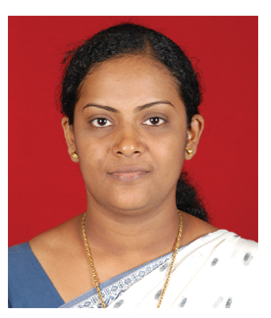  PRIYA ACHAMMA JACOB
 | Designation | ASSOSIATE PROFESSOR
 | Department | CIVIL ENGG:
 | Date of Joining the Institution | 03-10-2016
 | Qualifications with Class/Grade | M Tech - FIRST CLASS Phd
 | Total Experience in Years | Teaching- Industry- Research- NIL
 | Papers Published | National- Nil International- Nil
 | Papers Presented in Conferences | National- Nil International- Nil
 | PhD Guide? Give field & University | Field- NIL University- NIL
 | PhDs / Projects Guided | PhDs - NIL Projects at Masters level- NIL
 | Books Published / IPRs/ Patents | Nil
 | Professional Memberships | Nil
 | Consultancy Activities | Nil
 | Awards | Nil
 | Grants fetched | Nil
 | Interaction with Professional Institutions | Nil

13.14 | Name of Teaching Staff* | 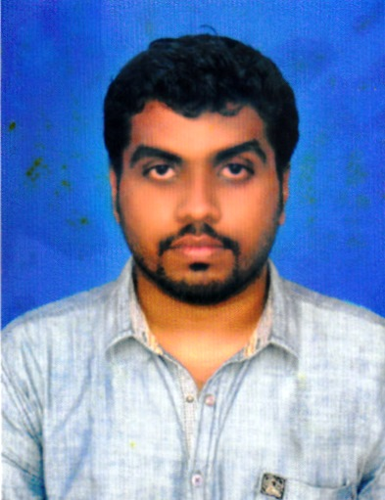  Prof. JANESH KRISHNAN
 | Designation | ASSISTANT PROFESSOR
 | Department | CIVIL ENIGINEERING:
 | Date of Joining the Institution | 30-07-2014
 | Qualifications with Class/Grade | BTech - FIRST CLASS MTech - FIRST CLASS
 | Total Experience in Years | Teaching-3 Industry- 1 Research- NIL
 | Papers Published | National- Nil International- Nil
 | Papers Presented in Conferences | National- Nil International- Nil
 | PhD Guide? Give field & University | Field- NIL University- NIL
 | PhDs / Projects Guided | PhDs - NIL Projects at Masters level- NIL
 | Books Published / IPRs/ Patents | Nil
 | Professional Memberships | Nil
 | Consultancy Activities | Nil
 | Awards | Nil
 | Grants fetched | Nil
 | Interaction with Professional Institutions | Nil

13.15 | Name of Teaching Staff* | 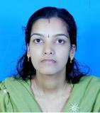  Prof. PRIYA A
 | Designation | ASSISTANT PROFESSOR
 | Department | CIVIL ENIGINEERING:
 | Date of Joining the Institution | 04-07-2016
 | Qualifications with Class/Grade | BTech - FIRST CLASS MTech - FIRST CLASS
 | Total Experience in Years | Teaching-4 Industry- 1 Research- NIL
 | Papers Published | National- Nil International- Nil
 | Papers Presented in Conferences | National- Nil International- Nil
 | PhD Guide? Give field & University | Field- NIL University- NIL
 | PhDs / Projects Guided | PhDs - NIL Projects at Masters level- NIL
 | Books Published / IPRs/ Patents | Nil
 | Professional Memberships | Nil
 | Consultancy Activities | Nil
 | Awards | Nil
 | Grants fetched | Nil
 | Interaction with Professional Institutions | Nil

13.16 | Name of Teaching Staff* | 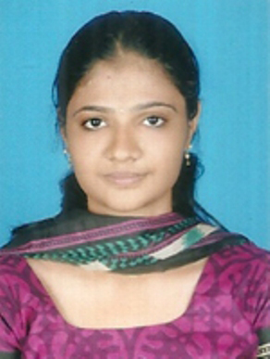  Prof. SRUTHI T K
 | Designation | ASSISTANT PROFESSOR
 | Department | CIVIL ENIGINEERING:
 | Date of Joining the Institution | 26-10-2015
 | Qualifications with Class/Grade | BTech - FIRST CLASS MTech - FIRST CLASS
 | Total Experience in Years | Teaching-1 Industry- 1 Research- NIL
 | Papers Published | National- Nil International- Nil
 | Papers Presented in Conferences | National- Nil International- Nil
 | PhD Guide? Give field & University | Field- NIL University- NIL
 | PhDs / Projects Guided | PhDs - NIL Projects at Masters level- NIL
 | Books Published / IPRs/ Patents | Nil
 | Professional Memberships | Nil
 | Consultancy Activities | Nil
 | Awards | Nil
 | Grants fetched | Nil
 | Interaction with Professional Institutions | Nil

13.17 | Name of Teaching Staff* | 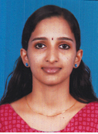  Prof. SRUTHI KOYITTI.
 | Designation | ASSISTANT PROFESSOR
 | Department | CIVIL ENGINEERING
 | Date of Joining the Institution | 11-09-2017
 | Qualifications with Class/Grade | BTech - FIRST CLASS MTech - FIRST CLASS
 | Total Experience in Years | Teaching- 1 Industry- NIL Research- NIL
 | Papers Published | National- NIL International- NIL
 | Papers Presented in Conferences | National- NIL International- NIL
 | PhD Guide? Give field & University | Field- NIL University- NIL
 | PhDs / Projects Guided | PhDs- NIL Projects at Masters level- NIL
 | Books Published / IPRs/ Patents | NIL
 | Professional Memberships | NIL
 | Consultancy Activities | NIL
 | Awards | NIL
 | Grants fetched | NIL
 | Interaction with Professional Institutions | NIL

13.18 | Name of Teaching Staff* | 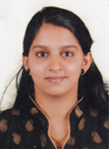  Prof. RAMYA M
 | Designation | ASSISTANT PROFESSOR
 | Department | CIVIL ENGINEERING
 | Date of Joining the Institution | 09-10-2017
 | Qualifications with Class/Grade | BTech - FIRST CLASS MTech - FIRST CLASS
 | Total Experience in Years | Teaching - 3 Industry - NIL Research - NIL
 | Papers Published | National - NIL International - NIL
 | Papers Presented in Conferences | National- NIL International- NIL
 | PhD Guide? Give field & University | Field- NIL University- NIL
 | PhDs / Projects Guided | PhDs- NIL Projects at Masters level- NIL
 | Books Published / IPRs/ Patents | NIL
 | Professional Memberships | NIL
 | Consultancy Activities | NIL
 | Awards | NIL
 | Grants fetched | NIL
 | Interaction with Professional Institutions | NIL

13.19 | Name of Teaching Staff* | 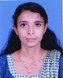  Prof. SANITHA N K
 | Designation | ASSISTANT PROFESSOR
 | Department | CIVIL ENGINEERING:
 | Date of Joining the Institution | 02-05-2014
 | Qualifications with Class/Grade | BSc - FIRST CLASS MSc - FIRST CLASS
 | Total Experience in Years | Teaching – 4 Industry - NIL Research - NIL
 | Papers Published | National - NIL International - NIL
 | Papers Presented in Conferences | National- NIL International- NIL
 | PhD Guide? Give field & University | Field- NIL University- NIL
 | PhDs / Projects Guided | PhDs- NIL Projects at Masters level- NIL
 | Books Published / IPRs/ Patents | NIL
 | Professional Memberships | NIL
 | Consultancy Activities | NIL
 | Awards | NIL
 | Grants fetched | NIL
 | Interaction with Professional Institutions | NIL

13.20 | Name of Teaching Staff* | 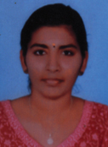  Prof. ANAGHA K
 | Designation | ASSISTANT PROFESSOR
 | Department | CIVIL ENGINEERING
 | Date of Joining the Institution | 08-01-2017
 | Qualifications with Class/Grade | BTech - FIRST CLASS MTech - FIRST CLASS
 | Total Experience in Years | Teaching -1 Industry - NIL Research - NIL
 | Papers Published | National - NIL International - NIL
 | Papers Presented in Conferences | National- NIL International- NIL
 | PhD Guide? Give field & University | Field- NIL University- NIL
 | PhDs / Projects Guided | PhDs- NIL Projects at Masters level- NIL
 | Books Published / IPRs/ Patents | NIL
 | Professional Memberships | NIL
 | Consultancy Activities | NIL
 | Awards | NIL
 | Grants fetched | NIL
 | Interaction with Professional Institutions | NIL

13.21 | Name of Teaching Staff* | 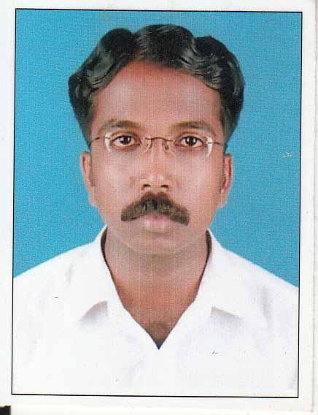  Prof. RAGHU T V
 | Designation | ASSISTANT PROFESSOR
 | Department | COMPUTER SCIENCE AND ENGINEERING
 | Date of Joining the Institution | 19-06-2013
 | Qualifications with Class/Grade | BTech - FIRST CLASS M.Tech - FIRST CLASS
 | Total Experience in Years | Teaching - 7 Industry - Research
 | Papers Published | National - NIL International - NIL
 | Papers Presented in Conferences | National - NIL International - NIL
 | PhD Guide? Give field & University | Field - NIL University - NIL
 | PhDs / Projects Guided | PhDs - NIL Projects at Masters level - NIL
 | Books Published / IPRs/ Patents | NIL
 | Professional Memberships | NIL
 | Consultancy Activities | NIL
 | Awards | NIL
 | Grants fetched | NIL
 | Interaction with Professional Institutions | NIL

13.22 | Name of Teaching Staff* | 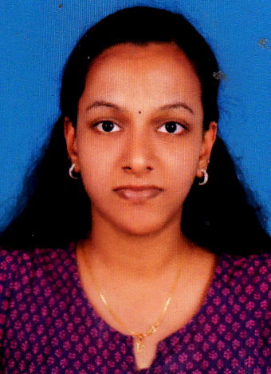  Prof. VINEETHA C
 | Designation | ASSISTANT PROFESSOR
 | Department | COMPUTER SCIENCE AND ENGINEERING:
 | Date of Joining the Institution | 02-07-2015
 | Qualifications with Class/Grade | BTech - FIRST CLASS M.Tech - FIRST CLASS
 | Total Experience in Years | Teaching - 1 Industry - Research
 | Papers Published | National - NIL International - NIL
 | Papers Presented in Conferences | National - NIL International - NIL
 | PhD Guide? Give field & University | Field - NIL University - NIL
 | PhDs / Projects Guided | PhDs - NIL Projects at Masters level - NIL
 | Books Published / IPRs/ Patents | NIL
 | Professional Memberships | NIL
 | Consultancy Activities | NIL
 | Awards | NIL
 | Grants fetched | NIL
 | Interaction with Professional Institutions | NIL

13.23 | Name of Teaching Staff* | 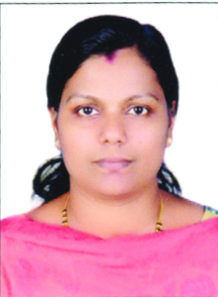  Prof. BABY SUNITHA VP
 | Designation | ASSISTANT PROFESSOR
 | Department | COMPUTER SCIENCE AND ENGINEERING:
 | Date of Joining the Institution | 14-01-2015
 | Qualifications with Class/Grade | BTech - FIRST CLASS M.Tech - FIRST CLASS
 | Total Experience in Years | Teaching - 5 Industry - 0 Research
 | Papers Published | National - NIL International - NIL
 | Papers Presented in Conferences | National - NIL International - NIL
 | PhD Guide? Give field & University | Field - NIL University - NIL
 | PhDs / Projects Guided | PhDs - NIL Projects at Masters level - NIL
 | Books Published / IPRs/ Patents | NIL
 | Professional Memberships | NIL
 | Consultancy Activities | NIL
 | Awards | NIL
 | Grants fetched | NIL
 | Interaction with Professional Institutions | NIL

13.24 | Name of Teaching Staff* | 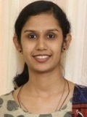  Prof. SRUTHI N PAUL
 | Designation | ASSISTANT PROFESSOR
 | Department | COMPUTER SCIENCE & ENGINEERING:
 | Date of Joining the Institution | 11-07-2016
 | Qualifications with Class/Grade | BTech - SECOND CLASS MTech - FIRST CLASS
 | Total Experience in Years | Teaching - 3 Industry - Research - NIL
 | Papers Published | National- NIL International- NIL
 | Papers Presented in Conferences | National- NIL International- NIL
 | PhD Guide? Give field & University | Field- NIL University- NIL
 | PhDs / Projects Guided | PhDs- NIL Projects at Masters level- NIL
 | Books Published / IPRs/ Patents | NIL
 | Professional Memberships | NIL
 | Consultancy Activities | NIL
 | Awards | NIL
 | Grants fetched | NIL
 | Interaction with Professional Institutions | NIL

13.25 | Name of Teaching Staff* | 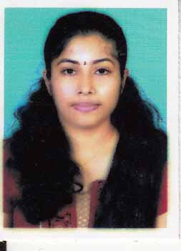  Prof. SRUTHI KRISHNAN
 | Designation | ASSISTANT PROFESSOR
 | Department | COMPUTER SCIENCE & ENGINEERING
 | Date of Joining the Institution | 01-01-2014
 | Qualifications with Class/Grade | BTech - FIRST CLASS MTech - FIRST CLASS
 | Total Experience in Years | Teaching- 2 Industry- NIL Research- NIL
 | Papers Published | National- NIL International- NIL
 | Papers Presented in Conferences | National- NIL International- NIL
 | PhD Guide? Give field & University | Field- NIL University- NIL
 | PhDs / Projects Guided | PhDs- NIL Projects at Masters level- NIL
 | Books Published / IPRs/ Patents | NIL
 | Professional Memberships | NIL
 | Consultancy Activities | NIL
 | Awards | NIL
 | Grants fetched | NIL
 | Interaction with Professional Institutions | NIL

13.26 | Name of Teaching Staff* | 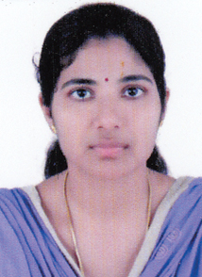  MRS. SRUTHI K
 | Designation | ASSISTANT PROFESSOR
 | Department | COMPUTER SCIENCE & ENGINEERING
 | Date of Joining the Institution | 11-07-2016
 | Qualifications with Class/Grade | B Tech - FIRST CLASS M Tech - FIRST CLASS
 | Total Experience in Years | Teaching -1 Industry- NIL Research- NIL
 | Papers Published | National- NIL International- NIL
 | Papers Presented in Conferences | National- NIL International- NIL
 | PhD Guide? Give field & University | Field- NIL University- NIL
 | PhDs / Projects Guided | PhDs- NIL Projects at Masters level- NIL
 | Books Published / IPRs/ Patents | NIL
 | Professional Memberships | NIL
 | Consultancy Activities | NIL
 | Awards | NIL
 | Grants fetched | NIL
 | Interaction with Professional Institutions | NIL

13.27 | Name of Teaching Staff* | 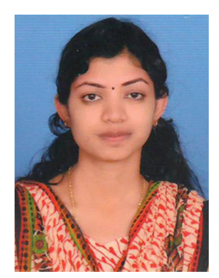  SUKINA K
 | Designation | ASSISTANT PROFESSOR
 | Department | COMPUTER SCIENCE & ENGG:
 | Date of Joining the Institution | 16-01-2017
 | Qualifications with Class/Grade | B Tech - FIRST CLASS M Tech - FIRST CLASS
 | Total Experience in Years | Teaching- Industry- Research- NIL
 | Papers Published | National- Nil International- Nil
 | Papers Presented in Conferences | National- Nil International- Nil
 | PhD Guide? Give field & University | Field- NIL University- NIL
 | PhDs / Projects Guided | PhDs - NIL Projects at Masters level- NIL
 | Books Published / IPRs/ Patents | Nil
 | Professional Memberships | Nil
 | Consultancy Activities | Nil
 | Awards | Nil
 | Grants fetched | Nil
 | Interaction with Professional Institutions | Nil

13.28 | Name of Teaching Staff* | 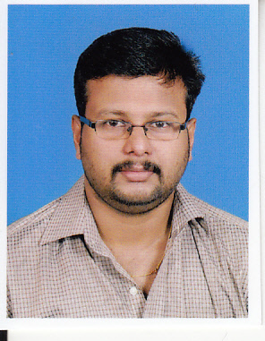  Prof. SOORAJ KP
 | Designation | ASSISTANT PROFESSOR
 | Department | COMPUTER SCIENCE AND ENGINEERING:
 | Date of Joining the Institution | 09-01-2012
 | Qualifications with Class/Grade | BCA - FIRST CLASS MCA - FIRST CLASS
 | Total Experience in Years | Teaching- 5 Industry-2 Research- NIL
 | Papers Published | National- Nil International- Nil
 | Papers Presented in Conferences | National- Nil International- Nil
 | PhD Guide? Give field & University | Field- NIL University- NIL
 | PhDs / Projects Guided | PhDs - NIL Projects at Masters level- NIL
 | Books Published / IPRs/ Patents | Nil
 | Professional Memberships | Nil
 | Consultancy Activities | Nil
 | Awards | Nil
 | Grants fetched | Nil
 | Interaction with Professional Institutions | Nil

13.29 | Name of Teaching Staff* | 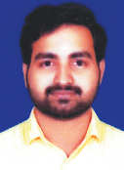  Prof. SREEJITH EMBRANTHIRI CV
 | Designation | ASSISTANT PROFESSOR
 | Department | COMPUTER SCIENCE AND ENGINEERING:
 | Date of Joining the Institution | 09-11-2017
 | Qualifications with Class/Grade | BTech - FIRST CLASS MTech - FIRST CLASS
 | Total Experience in Years | Teaching- 2 Industry- Research- NIL
 | Papers Published | National- Nil International- Nil
 | Papers Presented in Conferences | National- Nil International- Nil
 | PhD Guide? Give field & University | Field- NIL University- NIL
 | PhDs / Projects Guided | PhDs - NIL Projects at Masters level- NIL
 | Books Published / IPRs/ Patents | Nil
 | Professional Memberships | Nil
 | Consultancy Activities | Nil
 | Awards | Nil
 | Grants fetched | Nil
 | Interaction with Professional Institutions | Nil

13.30 | Name of Teaching Staff* | 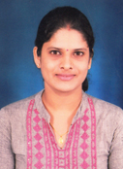  Prof. ASHA B SHETTY
 | Designation | ASSISTANT PROFESSOR
 | Department | COMPUTER SCIENCE AND ENGINEERING:
 | Date of Joining the Institution | 01-01-2018
 | Qualifications with Class/Grade | B.Tech - FIRST CLASS M.Tech - FIRST CLASS
 | Total Experience in Years | Teaching- 3 Industry- Research- NIL
 | Papers Published | National- Nil International- Nil
 | Papers Presented in Conferences | National- Nil International- Nil
 | PhD Guide? Give field & University | Field- NIL University- NIL
 | PhDs / Projects Guided | PhDs - NIL Projects at Masters level- NIL
 | Books Published / IPRs/ Patents | Nil
 | Professional Memberships | Nil
 | Consultancy Activities | Nil
 | Awards | Nil
 | Grants fetched | Nil
 | Interaction with Professional Institutions | Nil

13.31 | Name of Teaching Staff* | 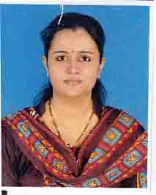  MRS. NITHA RANI M.
 | Designation | LECTURER
 | Department | COMPUTER SCIENCE & ENGINEERING:
 | Date of Joining the Institution | 01-09-2012
 | Qualifications with Class/Grade | BSc - SECOND CLASS MSc - FIRST CLASS
 | Total Experience in Years | Teaching- 3 Industry- 1 Research- NIL
 | Papers Published | National- NIL International- NIL
 | Papers Presented in Conferences | National- NIL International- NIL
 | PhD Guide? Give field & University | Field- NIL University- NIL
 | PhDs / Projects Guided | PhDs- NIL Projects at Masters level- NIL
 | Books Published / IPRs/ Patents | NIL
 | Professional Memberships | NIL
 | Consultancy Activities | NIL
 | Awards | NIL
 | Grants fetched | NIL
 | Interaction with Professional Institutions | NIL

13.32 | Name of Teaching Staff* | 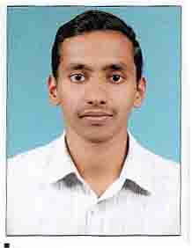  Prof. MANU THOMAS
 | Designation | ASSISTANT PROFESSOR
 | Department | ELECTRONICS & COMMUNICATION ENGG:
 | Date of Joining the Institution | 01-09-2012
 | Qualifications with Class/Grade | BTech - FIRST CLASS MTech - FIRST CLASS
 | Total Experience in Years | Teaching - 4 Industry - NIL Research - NIL
 | Papers Published | National - NIL International - NIL
 | Papers Presented in Conferences | National- NIL International- NIL
 | PhD Guide? Give field & University | Field- NIL University- NIL
 | PhDs / Projects Guided | PhDs- NIL Projects at Masters level- NIL
 | Books Published / IPRs/ Patents | NIL
 | Professional Memberships | NIL
 | Consultancy Activities | NIL
 | Awards | NIL
 | Grants fetched | NIL
 | Interaction with Professional Institutions | NIL

13.33 | Name of Teaching Staff* | 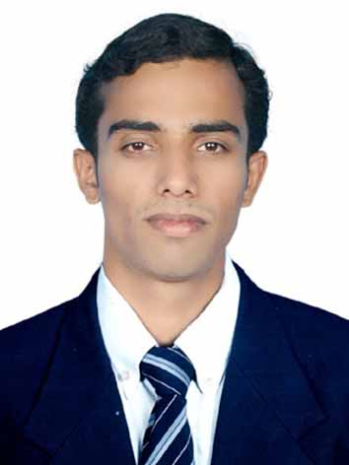  Prof. ANOOP AV
 | Designation | ASSISTANT PROFESSOR
 | Department | ELECTRONICS AND COMMUNICATIONS ENGINEERING
 | Date of Joining the Institution | 14-06-2013
 | Qualifications with Class/Grade | BTech - FIRST CLASS MTech - FIRST CLASS
 | Total Experience in Years | Teaching - 5 Industry - NIL Research - NIL
 | Papers Published | National - NIL International - NIL
 | Papers Presented in Conferences | National - NIL International - NIL
 | PhD Guide? Give field & University | Field - NIL University - NIL
 | PhDs / Projects Guided | PhDs - NIL Projects at Masters level - NIL
 | Books Published / IPRs/ Patents | NIL
 | Professional Memberships | NIL
 | Consultancy Activities | NIL
 | Awards | NIL
 | Grants fetched | NIL
 | Interaction with Professional Institutions | NIL

13.34 | Name of Teaching Staff* | 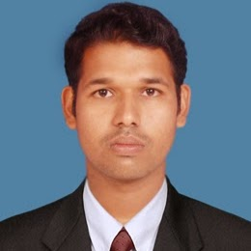  Prof. SRUTHIN BALACHANDRAN
 | Designation | ASSISTANT PROFESSOR
 | Department | ELECTRONICS & COMMUNICATION ENGG:
 | Date of Joining the Institution | 01-08-2014
 | Qualifications with Class/Grade | BTech - SECOND CLASS MTech - FIRST CLASS
 | Total Experience in Years | Teaching - 2 Industry - 9 Research - NIL
 | Papers Published | National - NIL International - NIL
 | Papers Presented in Conferences | National- NIL International- NIL
 | PhD Guide? Give field & University | Field- NIL University- NIL
 | PhDs / Projects Guided | PhDs- NIL Projects at Masters level- NIL
 | Books Published / IPRs/ Patents | NIL
 | Professional Memberships | NIL
 | Consultancy Activities | NIL
 | Awards | NIL
 | Grants fetched | NIL
 | Interaction with Professional Institutions | NIL

13.35 | Name of Teaching Staff* | 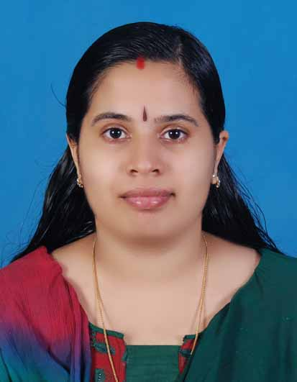  Prof. BINDU K P
 | Designation | ASSISTANT PROFESSOR
 | Department | ELECTRONICS & COMMUNICATION ENGG:
 | Date of Joining the Institution | 02-05-2014
 | Qualifications with Class/Grade | BTech - FIRST CLASS MTech - FIRST CLASS
 | Total Experience in Years | Teaching - 5 Industry - Research - NIL
 | Papers Published | National - NIL International - NIL
 | Papers Presented in Conferences | National- NIL International- NIL
 | PhD Guide? Give field & University | Field- NIL University- NIL
 | PhDs / Projects Guided | PhDs- NIL Projects at Masters level- NIL
 | Books Published / IPRs/ Patents | NIL
 | Professional Memberships | NIL
 | Consultancy Activities | NIL
 | Awards | NIL
 | Grants fetched | NIL
 | Interaction with Professional Institutions | NIL

13.36 | Name of Teaching Staff* | 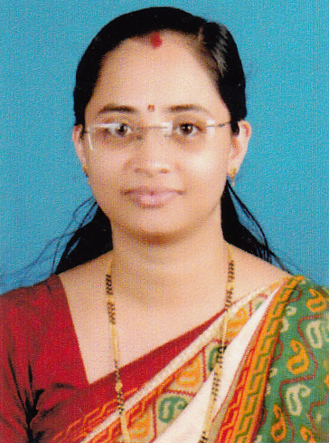  Prof. RADHIKA H
 | Designation | ASSISTANT PROFESSOR
 | Department | ELECTRONICS & COMMUNICATION ENGG:
 | Date of Joining the Institution | 30-12-2014
 | Qualifications with Class/Grade | BTech - FIRST CLASS MTech - FIRST CLASS
 | Total Experience in Years | Teaching - 8 Industry - Research - NIL
 | Papers Published | National - NIL International - NIL
 | Papers Presented in Conferences | National- NIL International- NIL
 | PhD Guide? Give field & University | Field- NIL University- NIL
 | PhDs / Projects Guided | PhDs- NIL Projects at Masters level- NIL
 | Books Published / IPRs/ Patents | NIL
 | Professional Memberships | NIL
 | Consultancy Activities | NIL
 | Awards | NIL
 | Grants fetched | NIL
 | Interaction with Professional Institutions | NIL

13.37 | Name of Teaching Staff* | 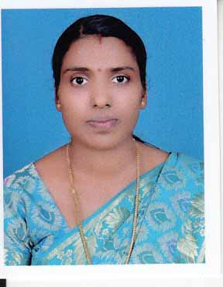  Prof. SOUMYA M
 | Designation | ASSISTANT PROFESSOR
 | Department | ELECTRONICS AND COMMUNICATIONS ENGINEERING
 | Date of Joining the Institution | 30-12-2013
 | Qualifications with Class/Grade | BTech - FIRST CLASS M Tech - FIRST CLASS
 | Total Experience in Years | Teaching- 3 Industry- NIL Research- NIL
 | Papers Published | National- NIL International- NIL
 | Papers Presented in Conferences | National- NIL International- NIL
 | PhD Guide? Give field & University | Field- NIL University- NIL
 | PhDs / Projects Guided | PhDs- NIL Projects at Masters level- NIL
 | Books Published / IPRs/ Patents | NIL
 | Professional Memberships | NIL
 | Consultancy Activities | NIL
 | Awards | NIL
 | Grants fetched | NIL
 | Interaction with Professional Institutions | NIL

13.38 | Name of Teaching Staff* | 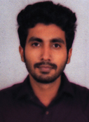  Prof. AKHIL SR
 | Designation | ASSISTANT PROFESSOR
 | Department | ELECTRONICS & COMMUNICATION ENGG:
 | Date of Joining the Institution | 08-01-2017
 | Qualifications with Class/Grade | BTech - FIRST CLASS MTech - FIRST CLASS
 | Total Experience in Years | Teaching- 2 Industry- Research- NIL
 | Papers Published | National- Nil International- Nil
 | Papers Presented in Conferences | National- Nil International- Nil
 | PhD Guide? Give field & University | Field- NIL University- NIL
 | PhDs / Projects Guided | PhDs - NIL Projects at Masters level- NIL
 | Books Published / IPRs/ Patents | Nil
 | Professional Memberships | Nil
 | Consultancy Activities | Nil
 | Awards | Nil
 | Grants fetched | Nil
 | Interaction with Professional Institutions | Nil

13.39 | Name of Teaching Staff* | 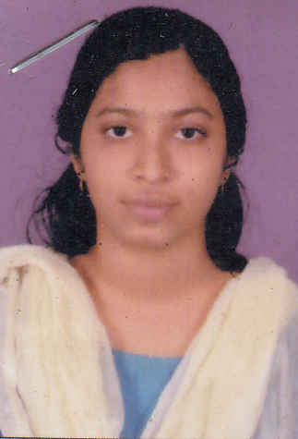  ANCY PV
 | Designation | ASSISTANT PROFESSOR
 | Department | ELECTRONICS & COMMUNICATION ENGG:
 | Date of Joining the Institution | 22-09-2016
 | Qualifications with Class/Grade | B Tech - FIRST CLASS M Tech - FIRST CLASS
 | Total Experience in Years | Teaching- Industry- Research- NIL
 | Papers Published | National- Nil International- Nil
 | Papers Presented in Conferences | National- Nil International- Nil
 | PhD Guide? Give field & University | Field- NIL University- NIL
 | PhDs / Projects Guided | PhDs - NIL Projects at Masters level- NIL
 | Books Published / IPRs/ Patents | Nil
 | Professional Memberships | Nil
 | Consultancy Activities | Nil
 | Awards | Nil
 | Grants fetched | Nil
 | Interaction with Professional Institutions | Nil

13.40 | Name of Teaching Staff* | 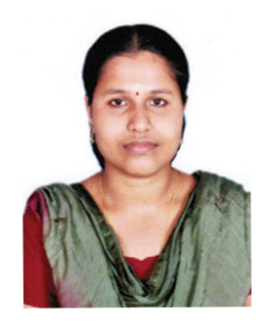  MEERA M
 | Designation | ASSISTANT PROFESSOR
 | Department | ELECTRONICS & COMMUNICATION ENGG:
 | Date of Joining the Institution | 16-01-2017
 | Qualifications with Class/Grade | B Tech - FIRST CLASS M Tech - FIRST CLASS
 | Total Experience in Years | Teaching- Industry- Research- NIL
 | Papers Published | National- Nil International- Nil
 | Papers Presented in Conferences | National- Nil International- Nil
 | PhD Guide? Give field & University | Field- NIL University- NIL
 | PhDs / Projects Guided | PhDs - NIL Projects at Masters level- NIL
 | Books Published / IPRs/ Patents | Nil
 | Professional Memberships | Nil
 | Consultancy Activities | Nil
 | Awards | Nil
 | Grants fetched | Nil
 | Interaction with Professional Institutions | Nil

13.41 | Name of Teaching Staff* | 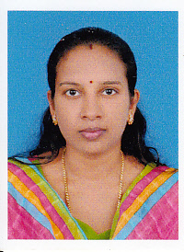  Prof. DHANYA K.
 | Designation | ASSISTANT PROFESSOR
 | Department | ELECTRICAL & ELECTRONICS ENGG:
 | Date of Joining the Institution | 01-09-2012
 | Qualifications with Class/Grade | BTech - SECOND CLASS MTech - FIRST CLASS
 | Total Experience in Years | Teaching - 4 Industry - 3 Research - NIL
 | Papers Published | National- NIL International- NIL
 | Papers Presented in Conferences | National- NIL International- NIL
 | PhD Guide? Give field & University | Field- NIL University- NIL
 | PhDs / Projects Guided | PhDs- NIL Projects at Masters level- NIL
 | Books Published / IPRs/ Patents | NIL
 | Professional Memberships | NIL
 | Consultancy Activities | NIL
 | Awards | NIL
 | Grants fetched | NIL
 | Interaction with Professional Institutions | NIL

13.42 | Name of Teaching Staff* | 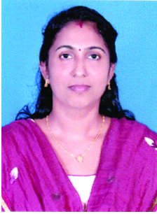  Prof. SANDHYA K
 | Designation | ASSISTANT PROFESSOR
 | Department | ELECTRICAL & ELECTRONICS ENGG:
 | Date of Joining the Institution | 12-11-2014
 | Qualifications with Class/Grade | BTech - FIRST CLASS ME - FIRST CLASS
 | Total Experience in Years | Teaching-4 Industry- Research- NIL
 | Papers Published | National- Nil International- Nil
 | Papers Presented in Conferences | National- Nil International- Nil
 | PhD Guide? Give field & University | Field- NIL University- NIL
 | PhDs / Projects Guided | PhDs - NIL Projects at Masters level- NIL
 | Books Published / IPRs/ Patents | Nil
 | Professional Memberships | Nil
 | Consultancy Activities | Nil
 | Awards | Nil
 | Grants fetched | Nil
 | Interaction with Professional Institutions | Nil

13.43 | Name of Teaching Staff* | 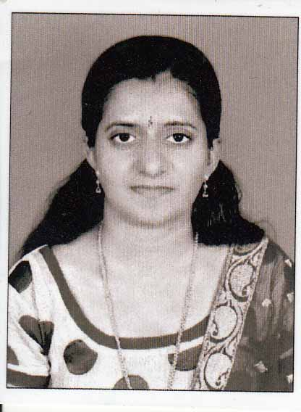  Prof. SRUTHI M
 | Designation | ASSISTANT PROFESSOR
 | Department | ELECTRICAL & ELECTRONICS ENGG:
 | Date of Joining the Institution | 17-06-2013
 | Qualifications with Class/Grade | BTech - FIRST CLASS ME - FIRST CLASS
 | Total Experience in Years | Teaching-5 Industry- Research- NIL
 | Papers Published | National- Nil International- Nil
 | Papers Presented in Conferences | National- Nil International- Nil
 | PhD Guide? Give field & University | Field- NIL University- NIL
 | PhDs / Projects Guided | PhDs - NIL Projects at Masters level- NIL
 | Books Published / IPRs/ Patents | Nil
 | Professional Memberships | Nil
 | Consultancy Activities | Nil
 | Awards | Nil
 | Grants fetched | Nil
 | Interaction with Professional Institutions | Nil

13.44 | Name of Teaching Staff* | 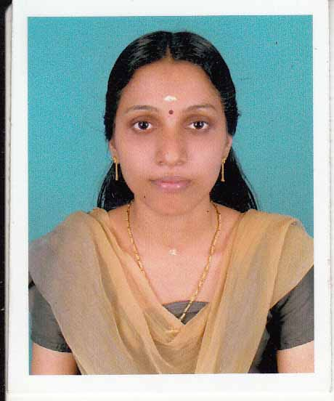  Prof. LAJITHA K V
 | Designation | ASSISTANT PROFESSOR
 | Department | ELECTRICAL AND ELECTRONICS ENGINEERING
 | Date of Joining the Institution | 17-06-2013
 | Qualifications with Class/Grade | BTech - FIRST CLASS ME - FIRST CLASS
 | Total Experience in Years | Teaching- 3 Industry- NIL Research- NIL
 | Papers Published | National- NIL International- NIL
 | Papers Presented in Conferences | National- NIL International- NIL
 | PhD Guide? Give field & University | Field- NIL University- NIL
 | PhDs / Projects Guided | PhDs- NIL Projects at Masters level- NIL
 | Books Published / IPRs/ Patents | NIL
 | Professional Memberships | NIL
 | Consultancy Activities | NIL
 | Awards | NIL
 | Grants fetched | NIL
 | Interaction with Professional Institutions | NIL

13.45 | Name of Teaching Staff* | 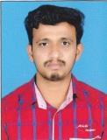  Prof. MANU C
 | Designation | ASSISTANT PROFESSOR
 | Department | ELECTRICAL & ELECTRONICS ENGG:
 | Date of Joining the Institution | 13-08-2013
 | Qualifications with Class/Grade | BTech - SECOND CLASS MTech - FIRST CLASS
 | Total Experience in Years | Teaching - 4 Industry - 3 Research - NIL
 | Papers Published | National- NIL International- NIL
 | Papers Presented in Conferences | National- NIL International- NIL
 | PhD Guide? Give field & University | Field- NIL University- NIL
 | PhDs / Projects Guided | PhDs- NIL Projects at Masters level- NIL
 | Books Published / IPRs/ Patents | NIL
 | Professional Memberships | NIL
 | Consultancy Activities | NIL
 | Awards | NIL
 | Grants fetched | NIL
 | Interaction with Professional Institutions | NIL

13.46 | Name of Teaching Staff* | 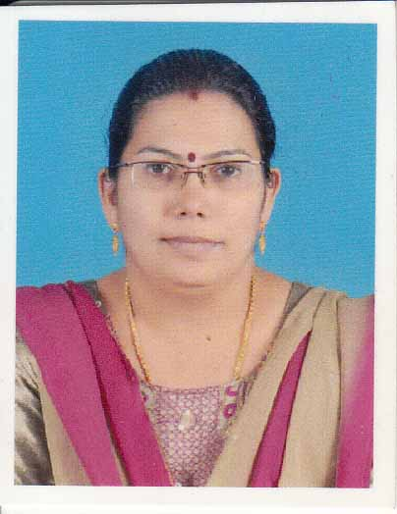  Prof. CHALANA K
 | Designation | ASSISTANT PROFESSOR
 | Department | APPLIED SCIENCE & HUMANITIES:
 | Date of Joining the Institution | 17-06-2013
 | Qualifications with Class/Grade | BA - SECOND CLASS MA - SECOND CLASS
 | Total Experience in Years | Teaching- 3 Industry- NIL Research- NIL
 | Papers Published | National- NIL International- NIL
 | Papers Presented in Conferences | National- NIL International- NIL
 | PhD Guide? Give field & University | Field- NIL University- NIL
 | PhDs / Projects Guided | PhDs- NIL Projects at Masters level- NIL
 | Books Published / IPRs/ Patents | NIL
 | Professional Memberships | NIL
 | Consultancy Activities | NIL
 | Awards | NIL
 | Grants fetched | NIL
 | Interaction with Professional Institutions | NIL

13.47 | Name of Teaching Staff* | 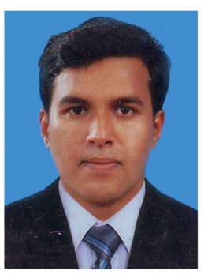  Prof. RAJESH V
 | Designation | ASSISTANT PROFESSOR
 | Department | APPLIED SCIENCE & HUMANITIES:
 | Date of Joining the Institution | 28-01-2015
 | Qualifications with Class/Grade | B Com - FIRST CLASS MBA- FIRST CLASS
 | Total Experience in Years | Teaching - 3 Industry - Research
 | Papers Published | National - NIL International - NIL
 | Papers Presented in Conferences | National - NIL International - NIL
 | PhD Guide? Give field & University | Field - NIL University - NIL
 | PhDs / Projects Guided | PhDs - NIL Projects at Masters level - NIL
 | Books Published / IPRs/ Patents | NIL
 | Professional Memberships | NIL
 | Consultancy Activities | NIL
 | Awards | NIL
 | Grants fetched | NIL
 | Interaction with Professional Institutions | NIL

13.48 | Name of Teaching Staff* | 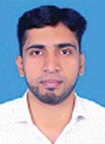  Prof. KABEER AHAMED MUTTATHODY
 | Designation | ASSISTANT PROFESSOR
 | Department | APPLIED SCIENCE & HUMANITIES:
 | Date of Joining the Institution | 08-03-2017
 | Qualifications with Class/Grade | B.A- FIRST CLASS MA - FIRST CLASS
 | Total Experience in Years | Teaching- 4 Industry- NIL Research- NIL
 | Papers Published | National- NIL International- NIL
 | Papers Presented in Conferences | National- NIL International- NIL
 | PhD Guide? Give field & University | Field- NIL University- NIL
 | PhDs / Projects Guided | PhDs- NIL Projects at Masters level- NIL
 | Books Published / IPRs/ Patents | NIL
 | Professional Memberships | NIL
 | Consultancy Activities | NIL
 | Awards | NIL
 | Grants fetched | NIL
 | Interaction with Professional Institutions | NIL

13.49 | Name of Teaching Staff* | 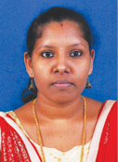  Prof. SOUMYA T
 | Designation | ASSISTANT PROFESSOR
 | Department | APPLIED SCIENCE & HUMANITIES:
 | Date of Joining the Institution | 03-09-2012
 | Qualifications with Class/Grade | BSc- FIRST CLASS B. Ed-  MSc- FIRST CLASS
 | Total Experience in Years | Teaching- 1 Industry- NIL Research- NIL
 | Papers Published | National- NIL International- NIL
 | Papers Presented in Conferences | National- NIL International- NIL
 | PhD Guide? Give field & University | Field- NIL University- NIL
 | PhDs / Projects Guided | PhDs- NIL Projects at Masters level- NIL
 | Books Published / IPRs/ Patents | NIL
 | Professional Memberships | NIL
 | Consultancy Activities | NIL
 | Awards | NIL
 | Grants fetched | NIL
 | Interaction with Professional Institutions | NIL

13.50 | Name of Teaching Staff* | 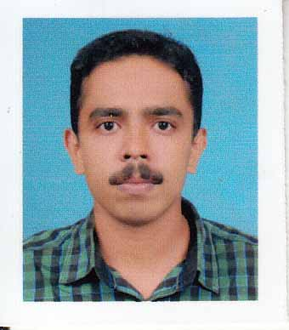  Prof. TONY SEBASTIAN
 | Designation | ASSISTANT PROFESSOR
 | Department | APPLIED SCIENCE & HUMANITIES:
 | Date of Joining the Institution | 17-06-2013
 | Qualifications with Class/Grade | BSc - FIRST CLASS MSc - FIRST CLASS
 | Total Experience in Years | Teaching – 3 Industry - NIL Research - NIL
 | Papers Published | National - NIL International - NIL
 | Papers Presented in Conferences | National- NIL International- NIL
 | PhD Guide? Give field & University | Field- NIL University- NIL
 | PhDs / Projects Guided | PhDs- NIL Projects at Masters level- NIL
 | Books Published / IPRs/ Patents | NIL
 | Professional Memberships | NIL
 | Consultancy Activities | NIL
 | Awards | NIL
 | Grants fetched | NIL
 | Interaction with Professional Institutions | NIL

13.51 | Name of Teaching Staff* | 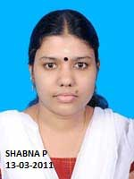  Prof. SHABNA P
 | Designation | ASSISTANT PROFESSOR
 | Department | APPLIED SCIENCE & HUMANITIES:
 | Date of Joining the Institution | 07-10-2013
 | Qualifications with Class/Grade | BSc - FIRST CLASS MSc - FIRST CLASS
 | Total Experience in Years | Teaching – 3 Industry - NIL Research - NIL
 | Papers Published | National - NIL International - NIL
 | Papers Presented in Conferences | National- NIL International- NIL
 | PhD Guide? Give field & University | Field- NIL University- NIL
 | PhDs / Projects Guided | PhDs- NIL Projects at Masters level- NIL
 | Books Published / IPRs/ Patents | NIL
 | Professional Memberships | NIL
 | Consultancy Activities | NIL
 | Awards | NIL
 | Grants fetched | NIL
 | Interaction with Professional Institutions | NIL

13.52 | Name of Teaching Staff* | 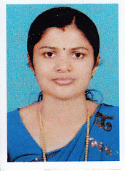  Prof. SHEENA P.
 | Designation | ASSISTANT PROFESSOR
 | Department | APPLIED SCIENCE & HUMANITIES:
 | Date of Joining the Institution | 03-09-2012
 | Qualifications with Class/Grade | BSc - FIRST CLASSS MSc - FIRST CLASS
 | Total Experience in Years | Teaching – 3 Industry -NIL Research- NIL
 | Papers Published | National- NIL International- NIL
 | Papers Presented in Conferences | National- NIL International- NIL
 | PhD Guide? Give field & University | Field- NIL University- NIL
 | PhDs / Projects Guided | PhDs- NIL Projects at Masters level- NIL
 | Books Published / IPRs/ Patents | NIL
 | Professional Memberships | NIL
 | Consultancy Activities | NIL
 | Awards | NIL
 | Grants fetched | NIL
 | Interaction with Professional Institutions | NIL

13.53 | Name of Teaching Staff* | 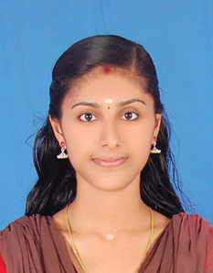  MISS. SRUTHI KP
 | Designation | ASSISTANT PROFESSOR
 | Department | APPLIED SCIENCE & HUMANITIES:
 | Date of Joining the Institution | 01-08-2016
 | Qualifications with Class/Grade | BSc - FIRST CLASS MSc - FIRST CLASS
 | Total Experience in Years | Teaching- 1 Industry- NIL Research- NIL
 | Papers Published | National- NIL International- NIL
 | Papers Presented in Conferences | National- NIL International- NIL
 | PhD Guide? Give field & University | Field- NIL University- NIL
 | PhDs / Projects Guided | PhDs- NIL Projects at Masters level- NIL
 | Books Published / IPRs/ Patents | NIL
 | Professional Memberships | NIL
 | Consultancy Activities | NIL
 | Awards | NIL
 | Grants fetched | NIL
 | Interaction with Professional Institutions | NIL

13.54 | Name of Teaching Staff* | 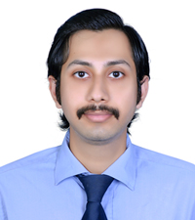  Prof. GURUPRASAD D
 | Designation | ASSISTANT PROFESSOR
 | Department | APPLIED SCIENCE & HUMANITIES:
 | Date of Joining the Institution | 17-10-2017
 | Qualifications with Class/Grade | B.Com - FIRST CLASS MBA - FIRST CLASS
 | Total Experience in Years | Teaching- 3 Industry- Research- NIL
 | Papers Published | National- Nil International- Nil
 | Papers Presented in Conferences | National- Nil International- Nil
 | PhD Guide? Give field & University | Field- NIL University- NIL
 | PhDs / Projects Guided | PhDs - NIL Projects at Masters level- NIL
 | Books Published / IPRs/ Patents | Nil
 | Professional Memberships | Nil
 | Consultancy Activities | Nil
 | Awards | Nil
 | Grants fetched | Nil
 | Interaction with Professional Institutions | Nil

13.55 | Name of Teaching Staff* | 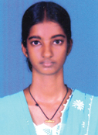  Prof. SRUTHI VENUGOPAL
 | Designation | ASSISTANT PROFESSOR
 | Department | APPLIED SCIENCE & HUMANITIES:
 | Date of Joining the Institution | 08-01-2017
 | Qualifications with Class/Grade | B. Sc - FIRST CLASS M. Sc - FIRST CLASS
 | Total Experience in Years | Teaching- Industry- Research- NIL
 | Papers Published | National- Nil International- Nil
 | Papers Presented in Conferences | National- Nil International- Nil
 | PhD Guide? Give field & University | Field- NIL University- NIL
 | PhDs / Projects Guided | PhDs - NIL Projects at Masters level- NIL
 | Books Published / IPRs/ Patents | Nil
 | Professional Memberships | Nil
 | Consultancy Activities | Nil
 | Awards | Nil
 | Grants fetched | Nil
 | Interaction with Professional Institutions | Nil

13.56 | Name of Teaching Staff* | 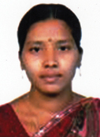  Prof. SUDEENA NADENDLA
 | Designation | ASSISTANT PROFESSOR
 | Department | APPLIED SCIENCE & HUMANITIES:
 | Date of Joining the Institution | 08-01-2017
 | Qualifications with Class/Grade | B. Sc - FIRST CLASS B.Ed  M. Sc - FIRST CLASS
 | Total Experience in Years | Teaching- 5 Industry- Research- NIL
 | Papers Published | National- Nil International- Nil
 | Papers Presented in Conferences | National- Nil International- Nil
 | PhD Guide? Give field & University | Field- NIL University- NIL
 | PhDs / Projects Guided | PhDs - NIL Projects at Masters level- NIL
 | Books Published / IPRs/ Patents | Nil
 | Professional Memberships | Nil
 | Consultancy Activities | Nil
 | Awards | Nil
 | Grants fetched | Nil
 | Interaction with Professional Institutions | Nil

13.57 | Name of Teaching Staff* | 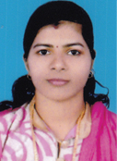  Prof. SUJANA K
 | Designation | ASSISTANT PROFESSOR
 | Department | APPLIED SCIENCE & HUMANITIES:
 | Date of Joining the Institution | 15-01-2018
 | Qualifications with Class/Grade | B. Sc - FIRST CLASS M. Sc - FIRST CLASS
 | Total Experience in Years | Teaching- 2 Industry- Research- NIL
 | Papers Published | National- Nil International- Nil
 | Papers Presented in Conferences | National- Nil International- Nil
 | PhD Guide? Give field & University | Field- NIL University- NIL
 | PhDs / Projects Guided | PhDs - NIL Projects at Masters level- NIL
 | Books Published / IPRs/ Patents | Nil
 | Professional Memberships | Nil
 | Consultancy Activities | Nil
 | Awards | Nil
 | Grants fetched | Nil
 | Interaction with Professional Institutions | Nil

13.58 | Name of Teaching Staff* | 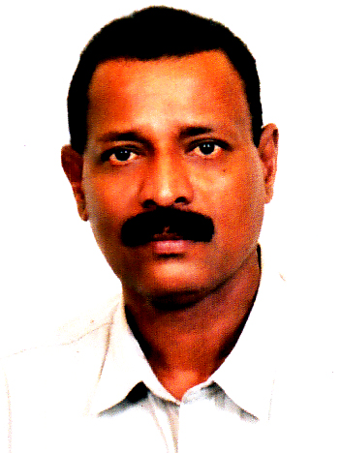  SASIDHARAN H V
 | Designation | ASSISTANT PROFESSOR
 | Department | PHYSICAL EDUCATION:
 | Date of Joining the Institution | 01-06-2015
 | Qualifications with Class/Grade | M Phil
 | Total Experience in Years | Teaching- Industry- Research- NIL
 | Papers Published | National- Nil International- Nil
 | Papers Presented in Conferences | National- Nil International- Nil
 | PhD Guide? Give field & University | Field- NIL University- NIL
 | PhDs / Projects Guided | PhDs - NIL Projects at Masters level- NIL
 | Books Published / IPRs/ Patents | Nil
 | Professional Memberships | Nil
 | Consultancy Activities | Nil
 | Awards | Nil
 | Grants fetched | Nil
 | Interaction with Professional Institutions | Nil

14 | Admission quota* | Government quota & Management Quota
 | Entrance test / admission criteria | Entrance Test conducted by Govt of Kerala (CEE)
 | Cut off / last candidate admitted | CAY & CAY-1 50% for Mathematics & 50% for PCM put together
 | Fees in rupees | Govt Quota Rs.40,000/- and Rs.65,000/- Management Quota Rs. 75,000/-
 | Number of Fee Waivers offered | CAY 0 CAY-1 0 CAY-2 0
 | Admission Calendar | From May/July Every year
 | PIO quota | No
15 | Infrastructural information
 | Classroom/Tutorial Room facilities | FOR PHOTOGRAPHS, PLEASE SEE ANNEXURE NO-4
 | Laboratory details | LABORATORIES ARE AVAILABLE AS PER KANNUR UNIVERSITY SYLLABUS -SEE ANNEXURE NO -5
 | Computer Centre facilities | 160 Systems with Intel Core I3 Processor, DDR-3, 2 GB Zion RAM, 500 GB HARD DISK, 17” Dell LCD Monitor -All Systems are connected with LAN-Reliance 2 mbps Contention ratio 1:1 Internet is available
 | Library facilities | SEE ANNEXURE NO-4
 | Auditorium / Seminar Halls / Amphi | Available
 | Cafeteria | Available
 | Indoor Sports facilities | Available
 | Outdoor Sports facilities | Available
 | Gymnasium facilities | Available
 | Facilities for disabled | Available
 | Any other facilities | STD Booth, Bus services, Hostels etc
16 | Boys Hostel | Rented building-Permanent building under construction
 | Girls Hostel | Rented building-Permanent building under construction
 | Medical & other Facilities at Hostel | Medical facility available
17 | Academic Sessions
 | Examination system, Year / Sem | Semester
 | Period of declaration of results | As per University notification
18 | Counseling / Mentoring
 | Career Counseling | Career Counseling facilities are available.
 | Medical facilities | Available with Part Time Medical Officer
 | Student Insurance | Available

19 | Students Activity Body
 | Cultural activities | Available
 | Sports activities | Available
 | Literary activities | Available
 | Magazine / Newsletter | Available
 | Technical activities / Tech-Fest | Available
 | Industrial Visits / Tours | Available
 | Alumni activities | First year of operation, yet to start
20 | Name of the Information Officer for RTI | MR. JACOB JOHN
 | Designation | Director
 | Phone number with STD code | 0467-2440024
 | FAX number with STD code | 04985-205907
 | Email | director@nmitkerala.ac.in

Annexure No-1
BOARD OF GOVERNORS
S.NO | NAME | DESIGNATION | Represented by
1 | Dr Gangan Prathap | Chairman | Trust
2 | K. P. Balakrishnan | Member | Trust
3 | Jacob John | Member | Trust
4 | K. P. Ganeshan | Member | Trust
5 | K. V. Ravindran | Member | Trust
6 |  | Member | Nominee of AICTE
7 | Dr K Rajagopal | Member | Industrialist
8 |  | Member | University
9 |  | Member | State Govt
10 |  | Member | Technologist nominated by State Govt.
11 | Dr. Suresan Pareth | Member Secretary | Principal

Annexure No.2

ACADEMIC ADVISORY BODY

Dr Gangan Prathap
Dr K Rajagopal
Dr Vinod Veedu
Dr Harinder Singh Jagdev
K V Ravindran
Prof T P Radhakrishnan
C R Nambiar

Annexure No.3
Organizational Structure
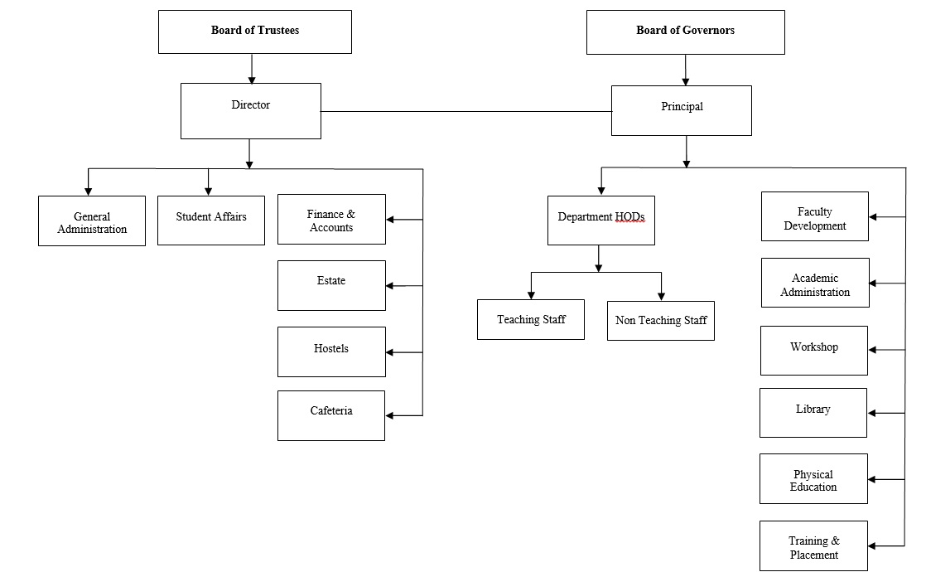

Annexure No.4

 | Classroom | 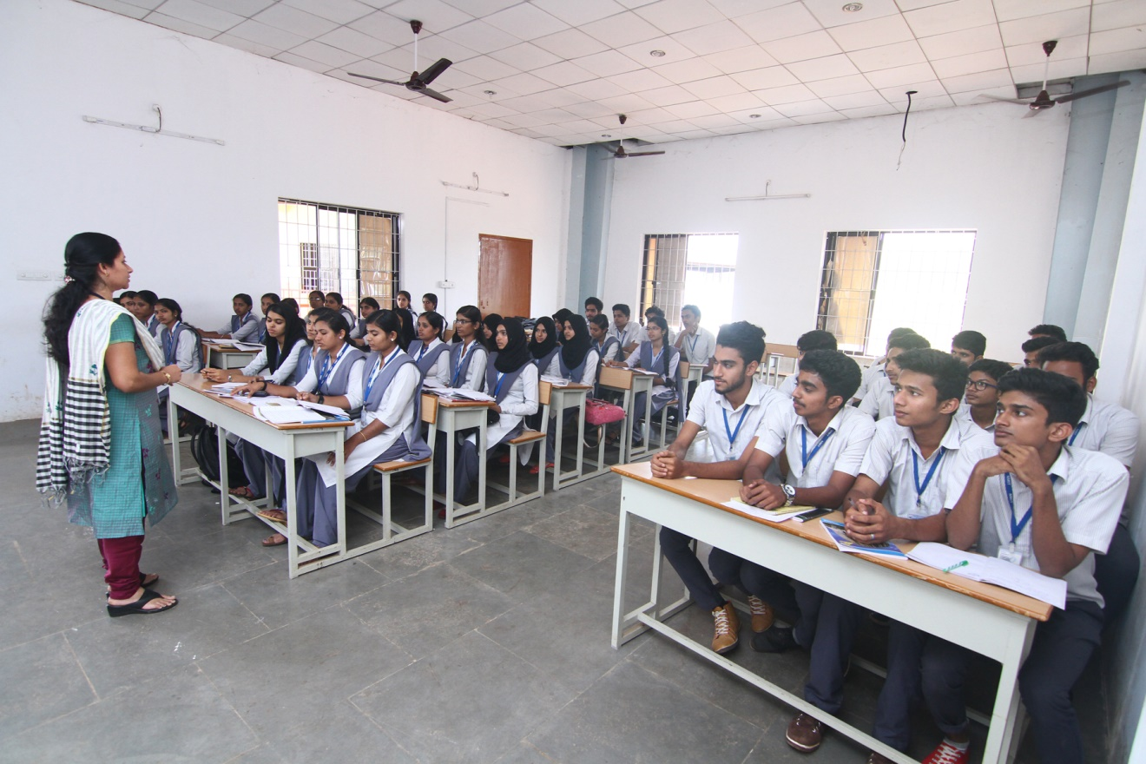
 | Tutorial Room facilities | 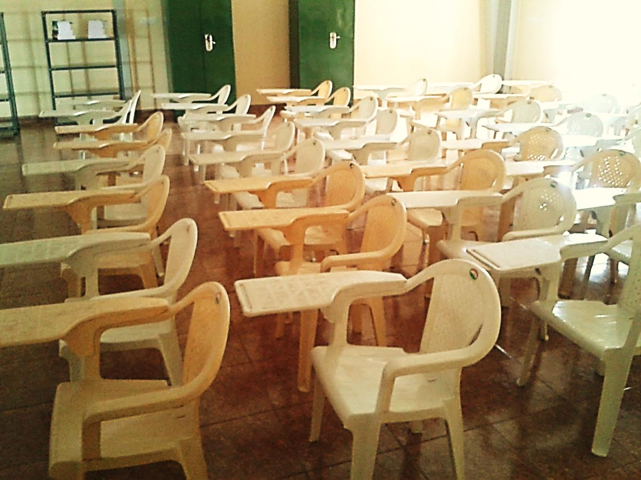

 | Workshop -1 | 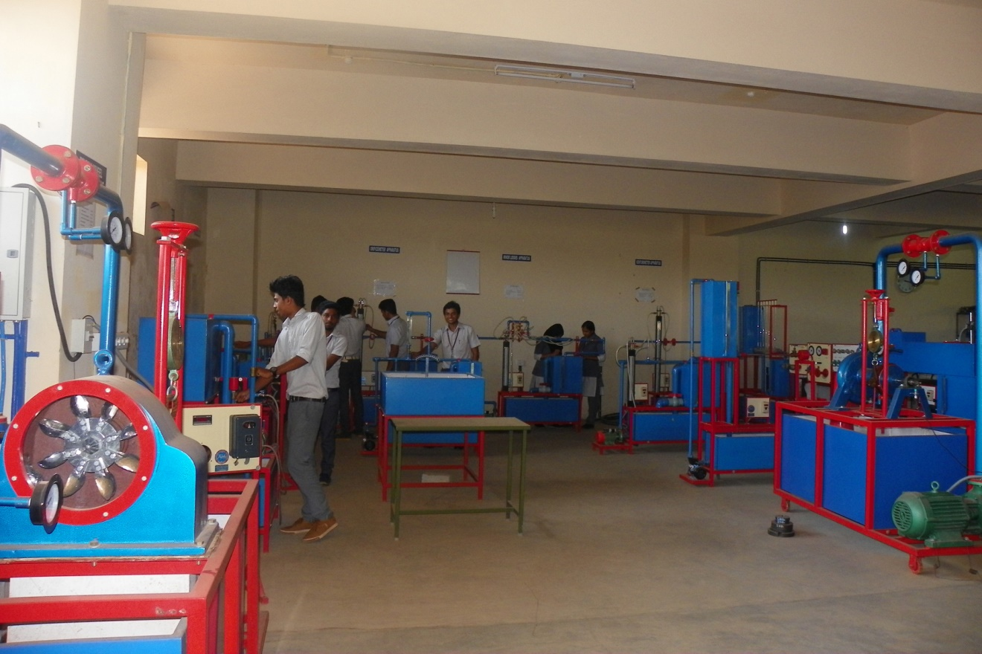
 | Workshop -2 | 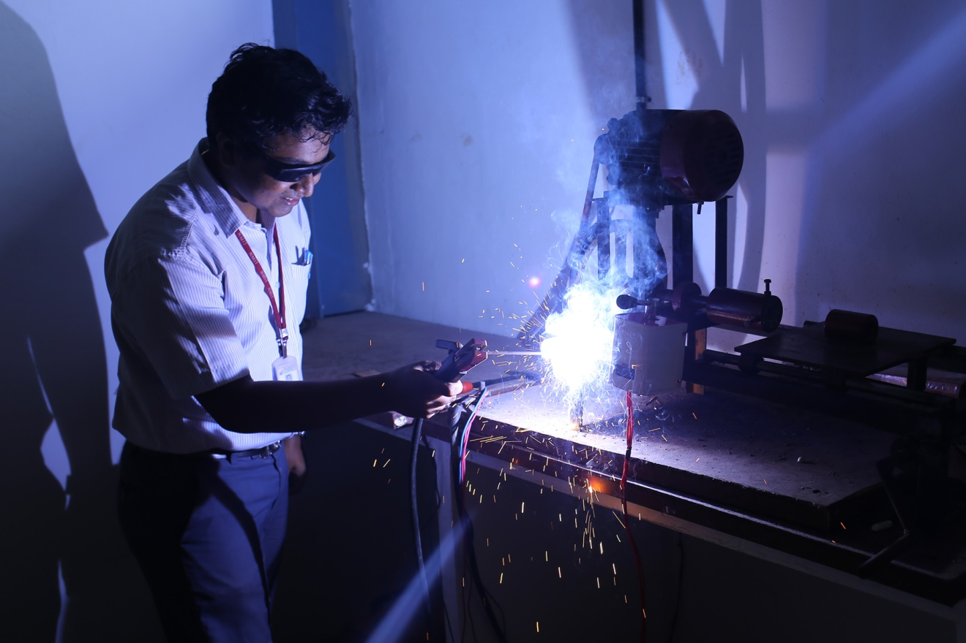

 | Electronics lab | 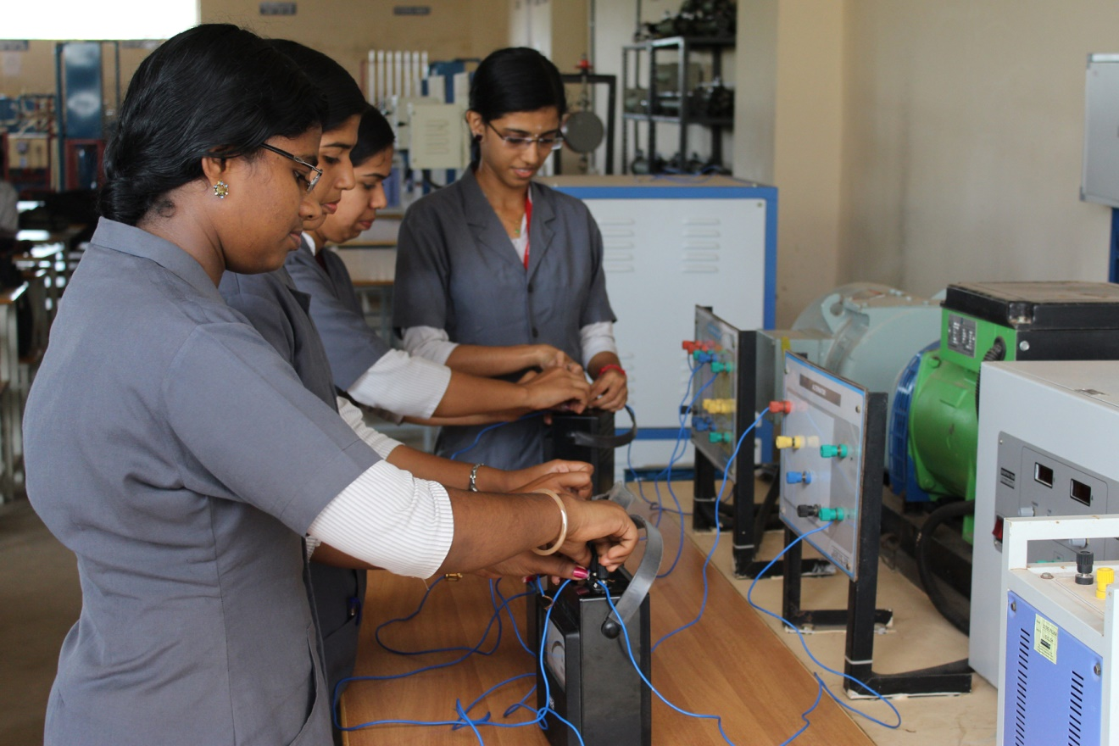

 | Electrical Lab | 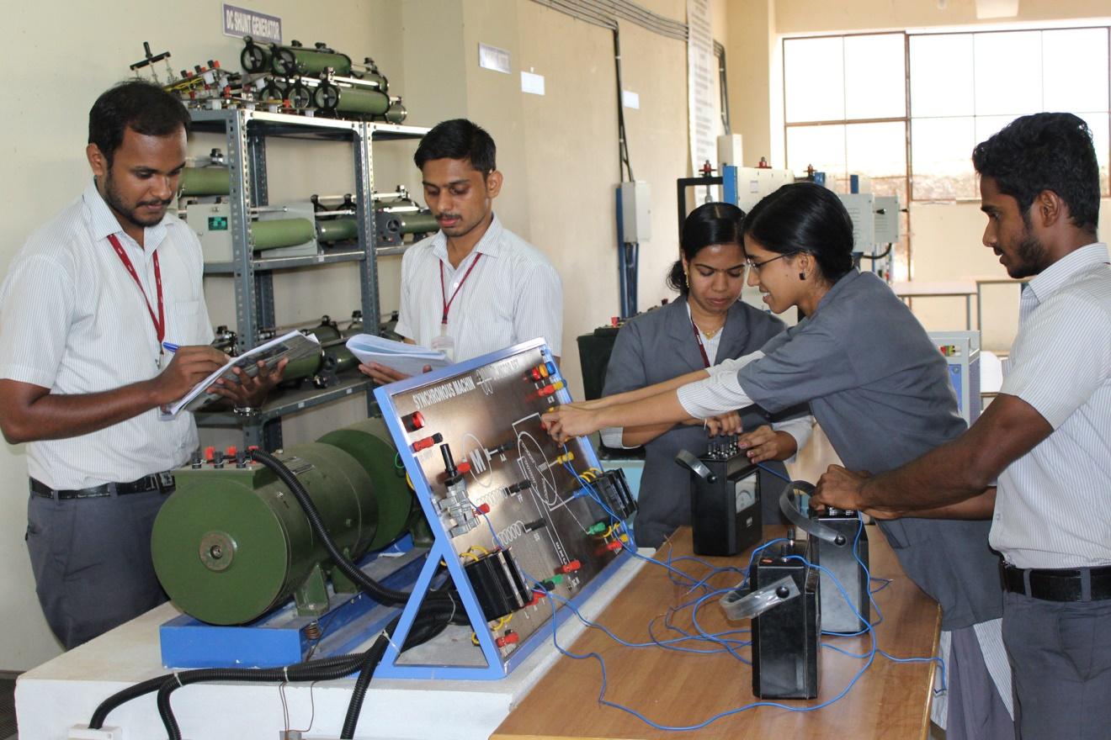
 | Mechanical LAB-1 | 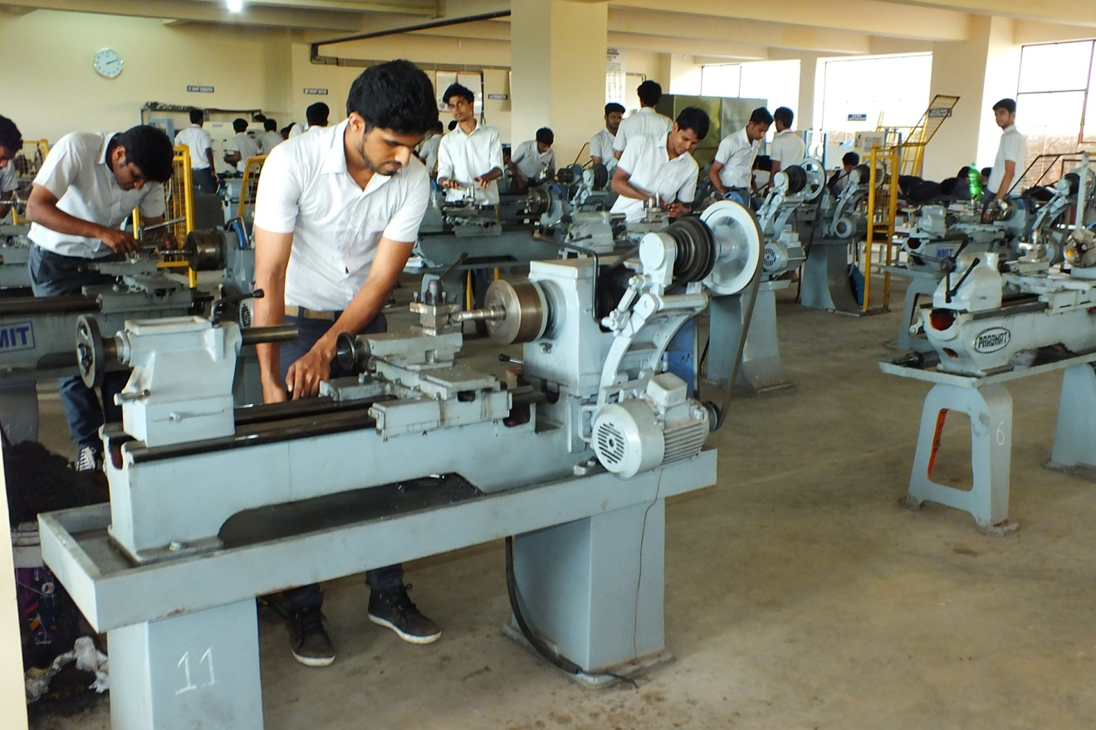
 | Mechanical LAB-2 | 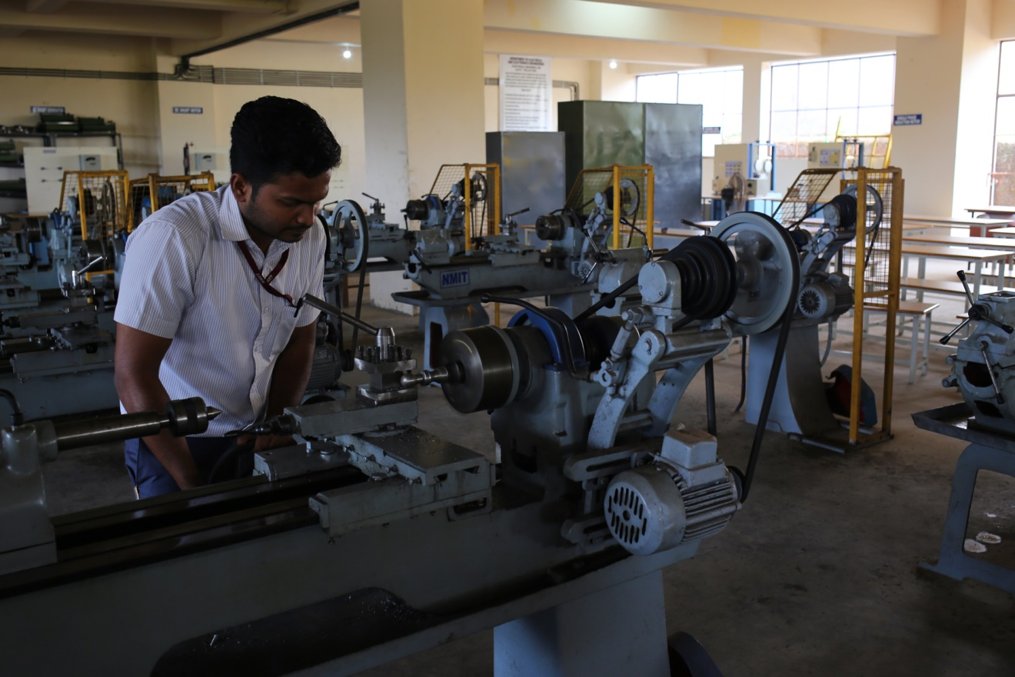

 | Computer Centre facilities | 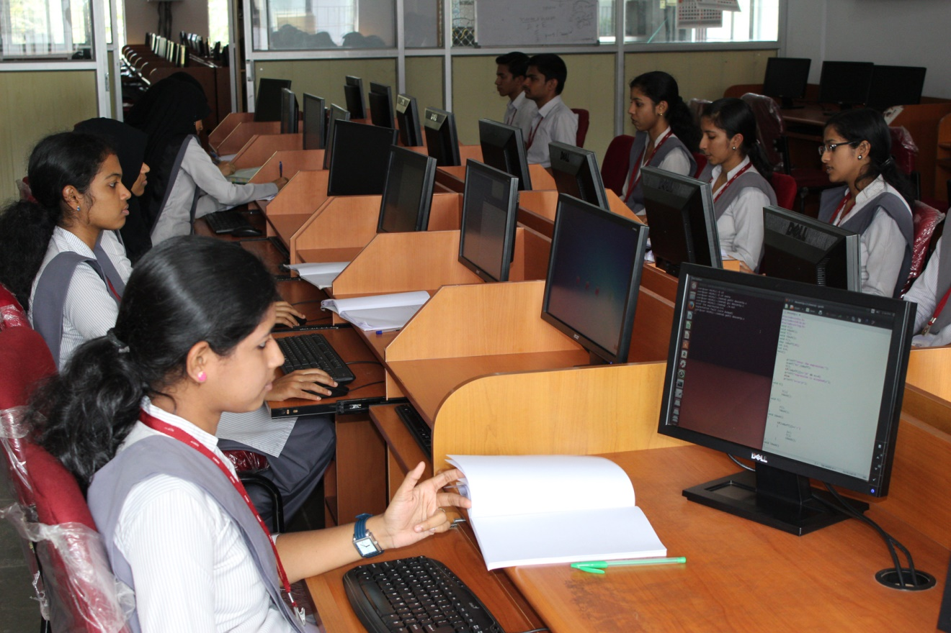
 | Language Lab facilities | 